Projectiles

Please remember to photocopy 4 pages onto one sheet by going A3→A4 and using back to back on the photocopier

This booklet contains every higher level (and most ordinary level) questions that have appeared on exam papers from 1971 – 2023
Note that this topic was usually Question 3 on the old syllabus (up to 2022)
Fully worked solutions from the legend that is Dominick Donnelly here appliedmathematics.ie/index.php/students/exam-solutions
Solutions to HL 2023 and Sample Paper (plus lots more) from Joe Kennedy here: https://www.jkmaths.net/exam-paper-solutions
Screencasts of worked solutions to HL 2023 and Sample Paper (plus lots more) from Shane Molloy here: https://www.molloymaths.com/applied-maths

Exam Papers (in pdf and Word format) plus Marking Schemes (and lots more) from: thephysicsteacher.ie/exammaterialappliedmaths.html
A good idea is to look at as many sources as you can for solutions as there is often more than one approach and some can be much easier to understand and/or remember than others.
Screencasts of worked solutions to various older past paper question plus comprehensive resources for all topics

Questions from 2023 and Sample Paper (Ordinary level and Higher level) are left until the very end – page 37

You can find this document plus all other Applied Maths booklets on the homepage of thephysicsteacher.ie

Last updated: 04/11/2023
Noel Cunningham
Table of Contents
Introduction: breaking velocity into two components 2
Guidelines on how to go about answering questions 4
Keys for answering questions 5
Projectiles keys: Test yourself 6
Ordinary Level Exam Questions 7
Particle fired horizontally 7
Initial velocity is given in terms of i and j components 10
Resolving the initial velocity into i and j components 11
Given the tan of the angle 13
Questions where the initial velocity is given in terms of the tan of the angle 14
Find the launch angle 15
Target Practice 16
Target Practice – straightforward Higher Level 18
Target Practice – tricky Higher Level 19
General questions 20
Some very difficult questions: as a final revision only 25
Maximum Range 27
Combining Collisions with Projectiles 29
Answers to ordinary level exam questions 30
Guide to answering higher level exam questions 33
Exam questions from 2023 and Sample Paper 37

Introduction: breaking velocity into two components

In analysing the motion of a projectile, it helps if we look at its motion in the horizontal and vertical direction separately.

Vertical motion
We know (don’t we?) that if we drop a ball it will accelerate towards the centre of the earth at a rate of 9.8 m s⁻².
Even if we throw the ball straight up it will still accelerate down at 9.8 m s⁻².
This is because the force of gravity is pulling it downward. The size of the acceleration and the direction of the acceleration is determined by gravity, nothing else. When thinking of these concepts, try not to think of acceleration in terms of velocity, but rather in terms of the force of gravity.

Neglecting air resistance, there is no other force acting on the object.

Now if we throw the object upwards at an angle there will still be this force of gravity acting on it in the vertical direction and so, regardless of the direction it’s moving, it is still accelerating downwards at 9.8 m s⁻².

Horizontal motion
There is no force acting on the ball in the horizontal direction (again neglecting air resistance) so we can say that acceleration in the horizontal direction is zero. Therefore the ball’s velocity in the horizontal direction is unchanging.
Consider a cannonball fired with horizontally with an initial velocity of 20 m s⁻¹. Its velocity in both the horizontal and vertical directions (known as the ‘x’ and ‘y’ directions for short) at one second intervals can be represented as follows.

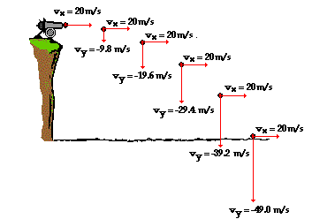

So to repeat, to answer questions based on the projectile’s motion we look at the ‘x’ and ‘y’ direction separately.
Usually we will only have enough information about one of the two directions and so we will work with that direction initially. Note that time is common to both directions, so we can use one direction to find the relevant time and then use this to help us find information about the second direction.
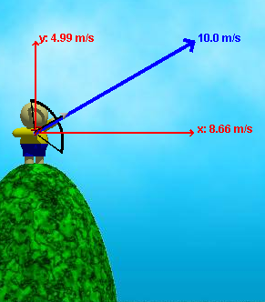

For the first few questions we are told the initial direction in the horizontal and vertical direction (we label these ‘Ux’ and ‘Uy’) but later we will have to work out Ux and Uy when given the magnitude of the initial velocity and the angle it is launched at.

Guidelines on how to go about answering questions

- Always start off with the following two columns

v_{x} = | v_{y} =
u_{x} = | u_{y} =
u_{x} = | u_{x} =
s_{x} = | s_{y} =
t = | t =

I refuse to help any student who is stuck but who doesn’t use this down as their starting pont.

Remember that the variables must all correspond to the same point on the particle’s trajectory,
i.e. if v_{y} = 0 then the t value must correspond to this particular time interval.

- Know the keys!
If you know the correct key (see next page) you should get most of the marks even if you go wrong later in the question, but if you don’t know the correct key you will get very few marks for the question regardless of what you do.

- You will need to have three pieces of information in either the x or the y direction to solve any of the vuast equations – this is your starting point.
Usually you will need to find time from one direction and then use this as part of your vuast in the other direction.



Keys for answering questions

What information on the vuast variables (in either the x or the y direction) can be taken from the following?

- If a bullet is fired horizontally what does it mean?
Answer:
u_{y} = 0

- If an object is fired from a cliff which is 200 metres above sea-level, how will this affect our approach to answering the question?
Answer:
S_{y} = - 200

- How would you find time of flight?
Answer:
Find t when s_{y} = 0.

- How would you find the range of a particle?
Answer:
Find t when s_{y} = 0 and sub this time in to s_{x}.

- How would you find the Maximum height reached by a particle?
Answer:
At maximum height v_{y} = 0, so find t from this and sub this value in to s_{y}.
Or
Use the equation v² = u² + 2as for the y-direction (which becomes 0 = u_{y}² + 2(-9.8)s)
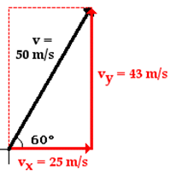
- How would you find the magnitude of a particle’s velocity after 3 seconds?
Answer:
First find v_{x} and v_{y} when t = 3. Magnitude is then found from the formula Magnitude = √ (v_{x}² + v_{y}²)

- How would you find the direction of a particle after 3 seconds?
Answer:
First find v_{x} and v_{y} when t = 3. Direction is then found from the formula
ϴ = Tan⁻¹ (v_{y} / v_{x})

- When would we ever take ‘g’ to be positive?
Answer:
When an object is given an initial velocity downwards (this rarely comes up).

- If a projectile just clears a wall (or hits a dart-board) which is 3 m away and 5 m high then . . .?
Answer:
S_{x} = 3 when S_{y} = 5

- If two projectiles collide in mid-air then . . .?
Answer:
- s_{y} for first projectile = s_{y} for second projectile
- s_{x} for first projectile plus s_{x} for second projectile equals the total distance between them at the beginning.

Projectiles keys: Test yourself

Note that time to reach maximum height is half of the time for full flight (if starting and finishing on horizontal ground).

- How would you find time of flight?

- How would you find the range of a particle?

- How would you find the Maximum height reached by a particle?

- How would you find the magnitude of a particle’s velocity after 3 seconds?

- How would you find the direction of a particle after 3 seconds?

- If an object is fired from a cliff which is 200 metres above sea-level, how will this affect our approach to answering the question?

- If a bullet is fired horizontally what does it mean?

- When would we ever take ‘g’ to be positive?

- If two projectiles collide in mid-air then . . .?

Ordinary Level Exam Questions

Remember to take g = 10 m s⁻² for all the Ordinary Level [OL] questions

Particle fired horizontally
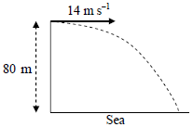
2015 (a) OL
A particle is projected horizontally with an initial speed of 14 m s^{‒1} from the top of a straight vertical cliff of height 80 m.
How far from the foot of the cliff will it hit the sea?

2005 (b) OL
A straight vertical cliff is 125 m high.
A projectile is fired horizontally with an initial speed of u m/s from the top of the cliff.
It strikes the level ground at a distance 375 √3 m from the foot of the cliff.
Find the value of u, correct to one decimal place.

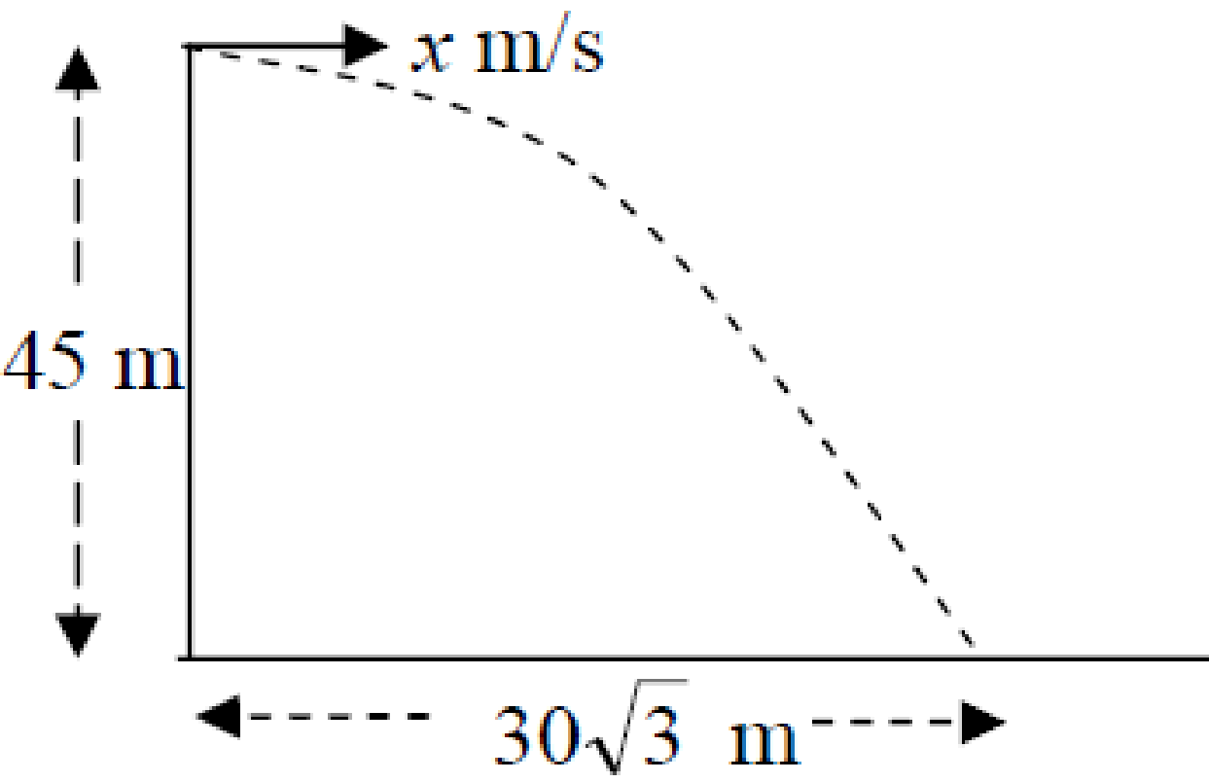
2009 (b) OL
A straight vertical cliff is 45 m high.
A projectile is fired horizontally with an initial speed of x m/s from the top of the cliff.
It strikes the level ground at a distance of 30√3 m from the foot of the cliff.
Find the value of x, correct to one decimal place.

2004 (a) OL
A smooth rectangular box is fixed to the horizontal ground.
A ball is moving with constant speed u m/s on the top of the box.
The ball is moving parallel to a side of the box.
The ball rolls a distance 2 m in a time of 0.5 seconds before falling over an edge of the box.
- Find the value of u.
- The ball strikes the horizontal ground at a distance of 4/√5 m from the bottom of the box.
Find the height of the box.

2002 OL (a)
A straight vertical cliff is 80 m high.
Projectile P is fired horizontally directly out to sea from the top of the cliff with a speed of x m/s.
Projectile P hits the sea at a distance of 80 m from the foot of the cliff.
- Find the time it takes projectile P to hit the sea.
- Find the value of x.

2002 OL (b) {this part is quite testing – feel free to leave it out first time around}
Note that this actually uses the information from 2002 (a) – this was quite confusing.
Another projectile, Q, is fired upwards at an angle α to the horizontal and with an initial speed of 15 m/s directly out to sea from the top of the cliff.
Projectile Q takes takes one second longer than projectile P to hit the sea.
- Show that sin α = 3/5.
- How far from the foot of the cliff does projectile Q hit the sea?

2001 OL (a)
A straight vertical cliff is 45 m high.
Projectile P is fired horizontally directly out to sea from the top of the cliff with a speed of 20 m/s.
- How long does it take projectile P to hit the sea?
- At what distance from the foot of the cliff does projectile P hit the sea?
2001 OL (b) {this part is quite testing – feel free to leave it out first time around}
Note that this actually uses the information from 2001 (a) – this was quite confusing.
Projectile Q is also fired directly out to sea from the top of the cliff with a velocity of xi + yj m/s, that is, with horizontal velocity component of x m/s and vertical velocity component of y m/s.
Projectile Q takes twice as long to hit the sea as projectile P did.
Projectile Q hits the sea three times as far from the foot of the cliff as projectile P did.
- Show that the value of x is 30 and find the value of y.

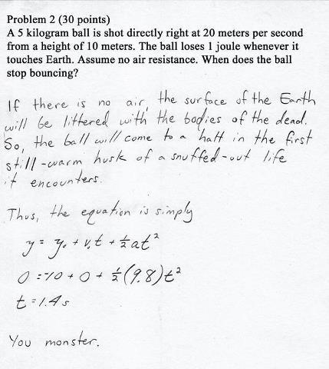

This is a compilation of a series of photos taken at equal time intervals.
What can you deduce about the displacement in the horizontal and vertical direction (strictly speaking we should be looking at the centre of gravity of the diver each time – his bellybutton)?

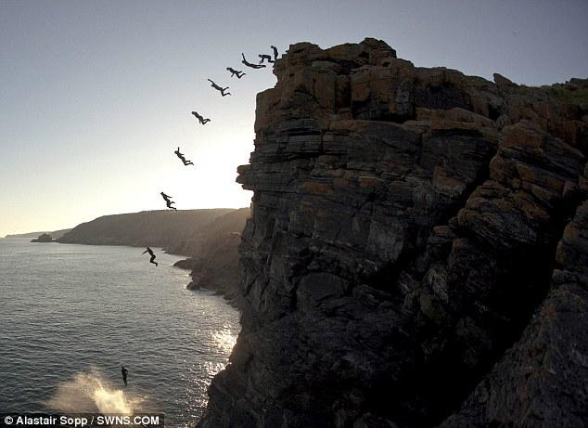

Initial velocity is given in terms of i and j components
2013 OL
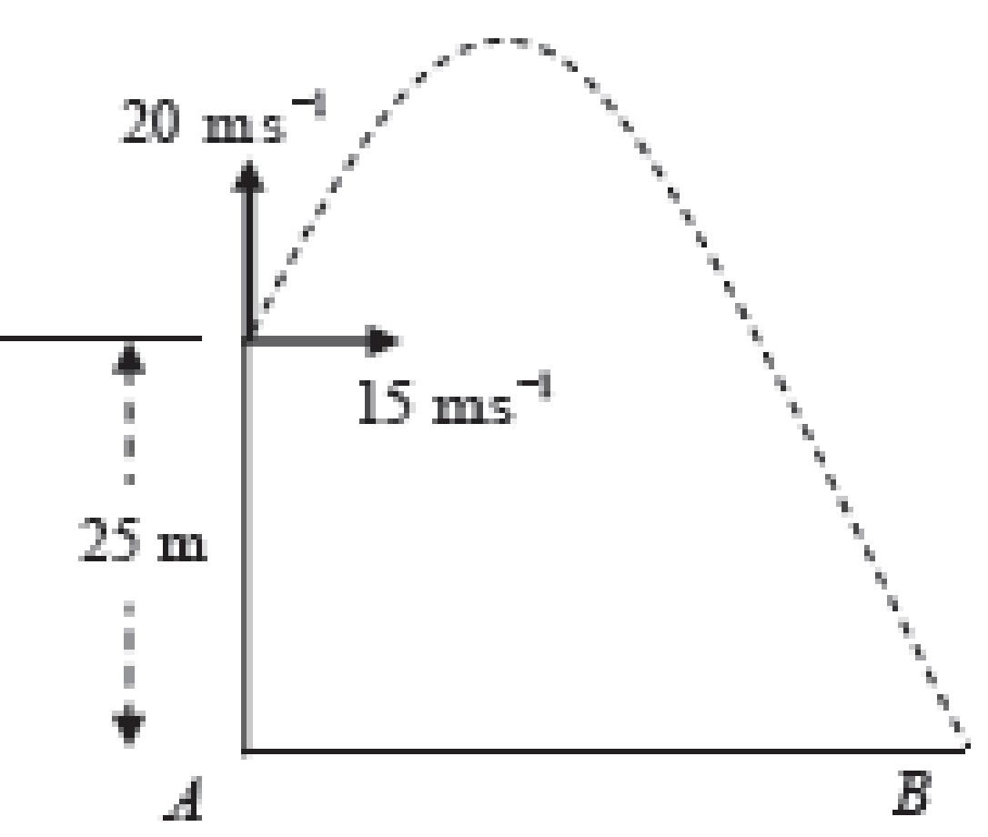
A particle is projected from the top of a straight vertical cliff of height 25 m with velocity 15i + 20 j.
It strikes the horizontal ground at B.
Find
- the time taken to reach the maximum height
- the maximum height above ground level
- the time of flight
- |AB|, the distance from A to B
- the speed of the particle as it strikes the ground.

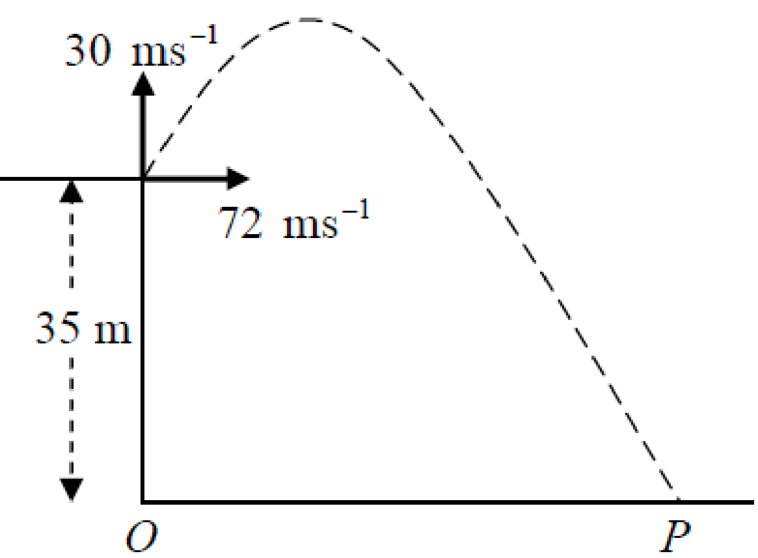
2010 OL
A particle is projected with initial velocity 72i + 30j m s⁻¹ from the top of a straight vertical cliff of height 35 m.
It strikes the horizontal ground at P.
Find
- the time taken to reach the maximum height
- the maximum height of the particle above ground level
- the time of flight
- |OP|, the distance from O to P
- the speed of the particle as it strikes the ground.

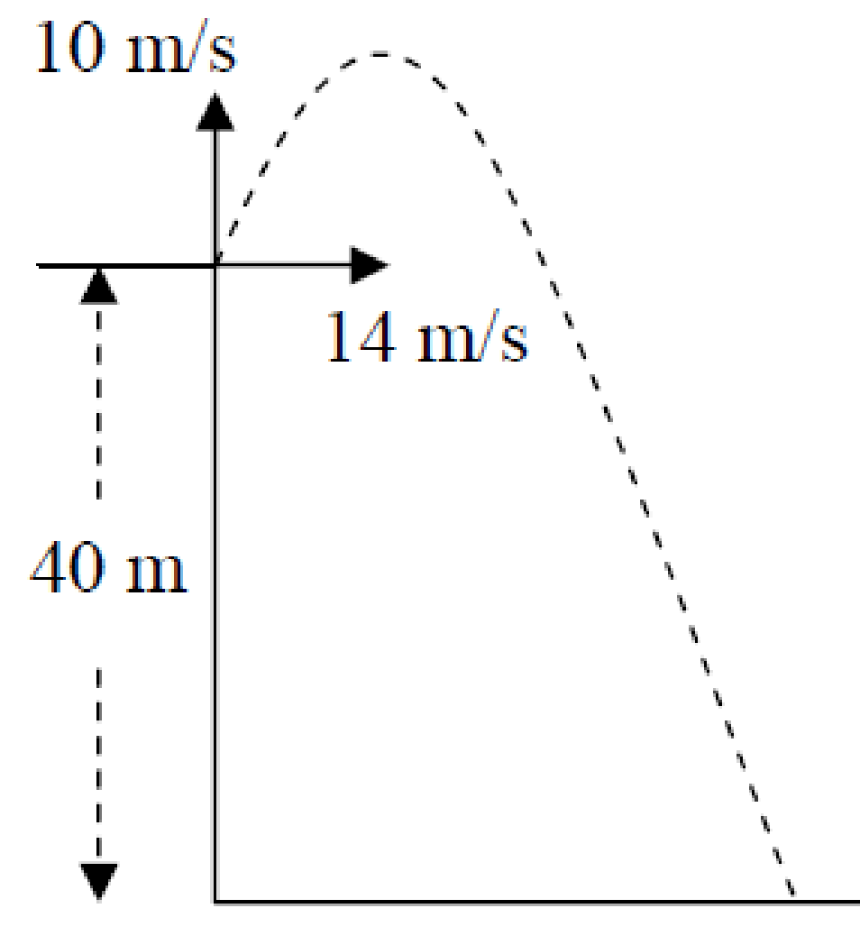
2007 OL
A projectile is fired with initial velocity 14i + 10j m/s from the top of a vertical cliff of height 40 m.
- Calculate the time taken to reach the maximum height.
- Calculate the maximum height of the projectile above ground level.
- Calculate the time it takes the projectile to travel from the maximum height to the ground.
- Find the range.
- Find the speed of the projectile as it strikes the ground.

2006 OL
A particle is projected from a point on a level horizontal plane with initial velocity 10i + 35j m/s, where i and j are unit perpendicular vectors in the horizontal and vertical directions respectively.
Find
- the time it takes to reach the maximum height
- the maximum height
- the two times when the particle is at a height of 50 m
- the speed with which the particle strikes the plane.

Resolving the initial velocity into i and j components

The opposite is equal to H Sin α
The adjacent is equal to H Cos α

First we need to remember that for a right-angled triangle:
Sin ⎝ = Opposite/Hypothenuse, therefore Opposite = Hypothenuse × Cos ⎝ {Opp = H Sin ⎝}
Cos ⎝ = Adjacent/Hypothenuse, therefore Adjacent = Hypothenuse × Cos ⎝ {Adj = H Cos ⎝}

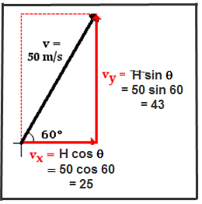
Example

Consider a velocity vector representing a initial velocity of 50 m s⁻¹ launched at an angle of 60⁰ to the horizontal.

The adjacent is equal to H Cos ⎝, which in this case = 50 cos 60⁰ = 25 m s⁻¹.
The opposite is equal to H Sin ⎝, which in this case = 50 sin 60⁰ = 43 m s⁻¹.

We would write this as follows: Ux = 25 i, Uy = 43 j.

The i and the j after the numbers tell us two things:
- these are vectors – quantities which have direction associated with them.
- The i is equivalent to the x direction and the j is equivalent to the y direction.

Fill in the following table (leave your angle in surd form where possible)
Magnitude | Angle | U_{x} | U_{y}
20 | 45⁰
10 | 30⁰
8 | 75⁰
20 | 60⁰
12 | 15⁰

2012 (a) OL
A ball is kicked from a point P on horizontal ground with a speed of 20 m s⁻¹ at 45° to the horizontal.
The ball strikes the ground at Q.
Find
- the time it takes the ball to travel from P to Q
- ⏐PQ⏐, the distance from P to Q.

Given the tan of the angle

For each of the following set of questions we won’t be told the launch angle directly, but rather the tan of the angle. If the information is given to us in the following format; tan β = 4/3, we can use this to find sin β and cos β without ever needing to know the angle β itself.
We do this by first drawing a small triangle to illustrate the relationship between sin, cos and tan for the given question.

Example:
A particle is projected from a point p on level horizontal ground with an initial speed of 100 m/s inclined at an angle α to the horizontal where tan α = ¾.
Use this information to the get Ux and Uy.

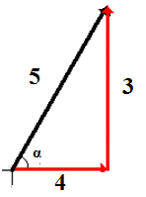
Solution
We know that the general expression for tan α is: $Tan α =\frac{Opposite}{Adjacent}$

So we draw a small right-angled triangle as shown and use Pythagoras’ theorem to find the length of the hypotenuse:
3² + 4² = x²
x = 5

Therefore from inspection

$Sin α=\frac{Opposite}{hypotenuse}=\frac{3}{5}$ and $Cos α =\frac{adjacent}{hypotenuse}= \frac{4}{5}$

The opposite is equal to H Sin α, which in this case = 100 (sin α) = 100($\frac{3}{5}$) = 60.
The adjacent is equal to H Cos α, which in this case = 100 (cos α) = 100($\frac{4}{5}$) = 80.

Answer:
Ux = 80
Uy = 60

Notice that
- We never needed to know what the actual angle itself is
- We didn’t need a calculator
- There is no rounding off so no unnecessary inaccuracies
- The whole process is quicker than if we had been provided with an actual angle

Questions where the initial velocity is given in terms of the tan of the angle

The opposite is equal to H Sin α
The adjacent is equal to H Cos α

Year | Initial speed (m/s) | tan β | U_{x} | U_{y}
2008 | 25 | $$\frac{4}{3}$$
2003 | 50 | $$\frac{3}{4}$$
2011 | 58 | $$\frac{20}{21}$$
2014 | 82 | $$\frac{40}{9}$$

2008 OL
A particle is projected from a point on horizontal ground with an initial speed of 25 m/s at an angle β⁰ to the horizontal where tan β = 4/3.
- Find the initial velocity of the particle in terms of i and j.
- Calculate the time taken to reach the maximum height.
- Calculate the maximum height of the particle above ground level.
- Find the range.
- Find the speed and direction of the particle after 3 seconds of motion.

2003 OL
A particle is projected from a point p on level horizontal ground with an initial speed of 50 m/s at an angle β to the horizontal, where tan β = 3/4.
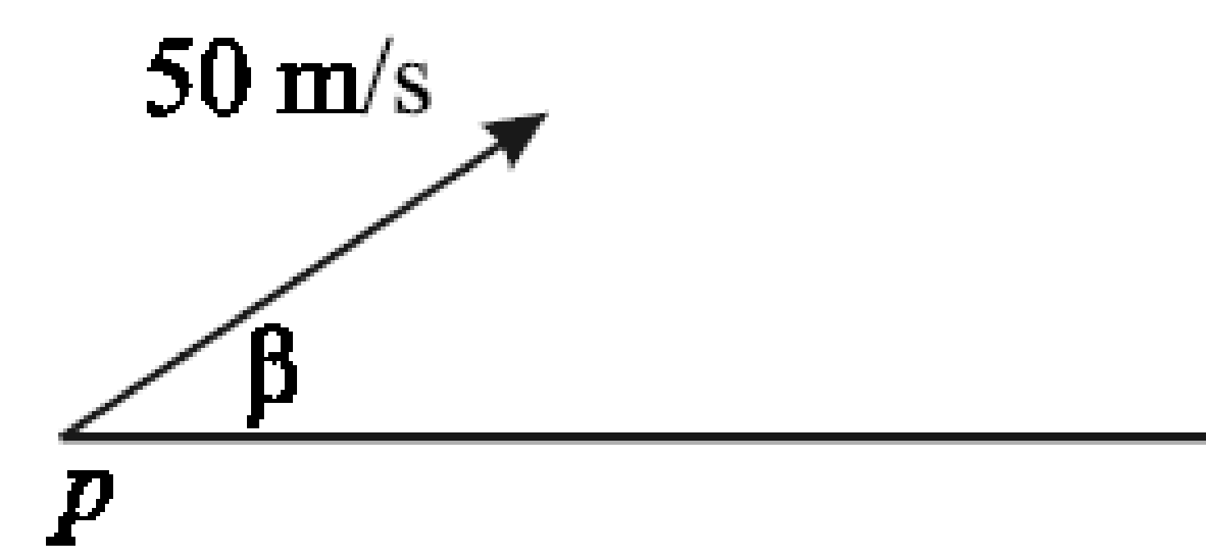
- Find the initial velocity of the particle in terms of i and j.

After 4 seconds in flight, the particle hits a target which is above the ground.
- Show that the distance from the point p to the target is 40√17 m.
- How far below the highest point reached by the particle is the target?
- Find, correct to the nearest m/s, the speed with which the particle hits the target.

2011 OL
A particle is projected from a point on horizontal ground with an initial speed of 58 m s⁻¹ at an angle β to the horizontal, where tan β = $\frac{20}{21}$.
- Find the initial velocity of the particle in terms of i and j.
- Calculate the time taken to reach the maximum height.
- Calculate the maximum height of the particle above ground level.
- Find the range.
- Find the two times at which the height of the particle is 75 m.

2014 OL
A particle is projected from a point on horizontal ground with an initial speed of 82 m s^{–1} at an angle β to the horizontal, where tan β = $\frac{40}{9}$.
Find
- the initial velocity of the particle in terms of i and j
- the time taken to reach the maximum height
- the maximum height of the particle above ground level
- the range
- the two times at which the height of the particle is 275 m.

2000 OL
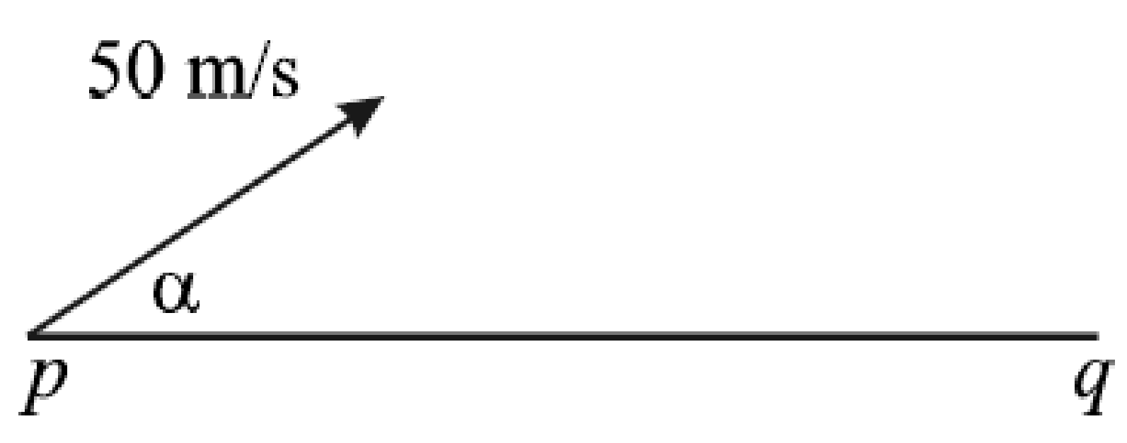
A particle is projected from a point p on level horizontal ground with an initial speed of 50 m/s inclined at an angle α to the horizontal where tan α = ¾.
The particle strikes the ground at the point q on the same horizontal level as p. Find
- the maximum height reached by the particle
- the time of flight
- ⏐pq⏐, the distance from p to q.

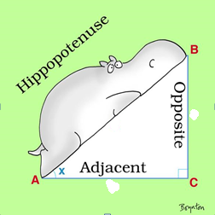

Find the launch angle

The opposite is equal to H Sin α
The adjacent is equal to H Cos α

Find the launch angle
2004 (b) OL
A golf ball is struck from a point r on the horizontal ground with a speed of 20 m/s at an angle θ to the horizontal ground. After 2√2 seconds, the ball strikes the ground at a point which is a horizontal distance of 40 m from r.
- Find the angle θ.

2005 (a) OL
A particle is projected from a point o on level horizontal ground with an initial speed of 50 √3 m/s at an angle β to the horizontal. It strikes the level ground at p after 15 seconds.
- Find the angle β.
- Find ⏐op⏐, the distance from o to p. Give your answer to the nearest metre.

Target Practice

For each of these questions you will be given some information about the target – in either the x or the y direction. This lets us know which direction to focus on initially.
Using it allows us to calculate t and we can then take this with us when looking at the perpendicular direction.

2015 (b) OL
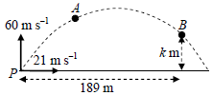
A particle is projected with initial velocity 21 i + 60 j m s^{‒1} from point P on a horizontal plane.

A and B are two points on the trajectory (path) of the particle.
The particle reaches point A after 4 seconds of motion.
The displacement of point B from P is 189 i + k j m.
Find
- the velocity of the particle at A in terms of i and j
- the speed and direction of the particle at A
- the value of k.

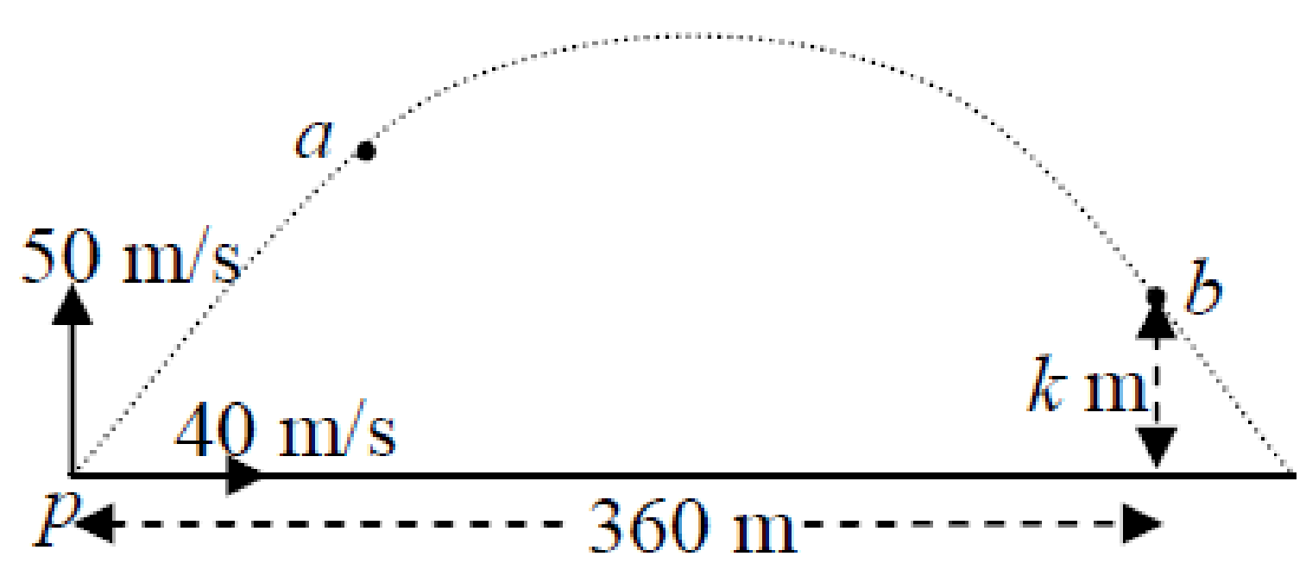
2009 (a) OL
A particle is projected with initial velocity 40i + 50j m/s from point p on a horizontal plane.
a and b are two points on the trajectory (path) of the particle.
The particle reaches point a after 2 seconds of motion.
The displacement of point b from p is 360i + kj metres.
Find
- the velocity of the particle at a in terms of i and j
- the speed and direction of the particle at a
- the value of k.

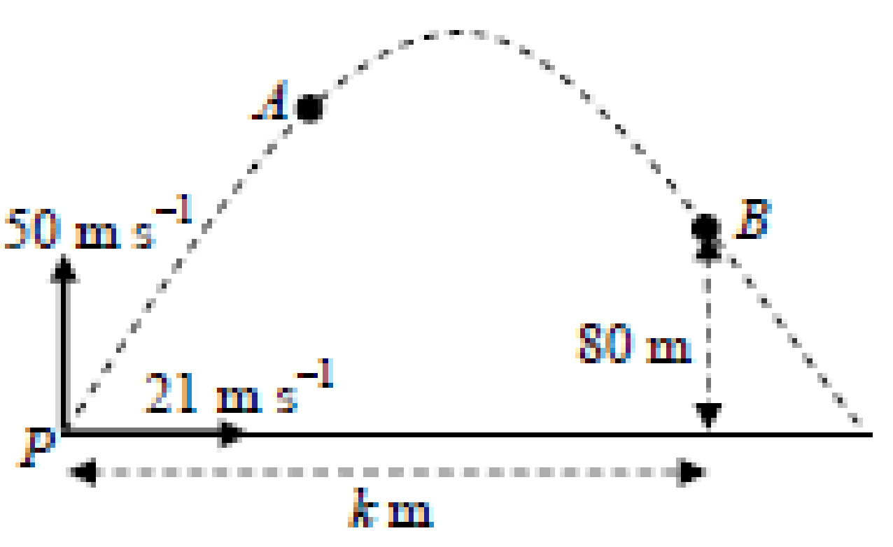
2012 (b) OL
A particle is projected with initial velocity 21i + 50j m s⁻¹ from point P on a horizontal plane.
A and B are two points on the trajectory (path) of the particle.
The particle reaches point A after 3 seconds of motion.
The displacement of point B from P is ki + 80j metres.
Find
(i) the velocity of the particle at A in terms of i and j
(ii) the speed and direction of the particle at A
(iii) the value of k.

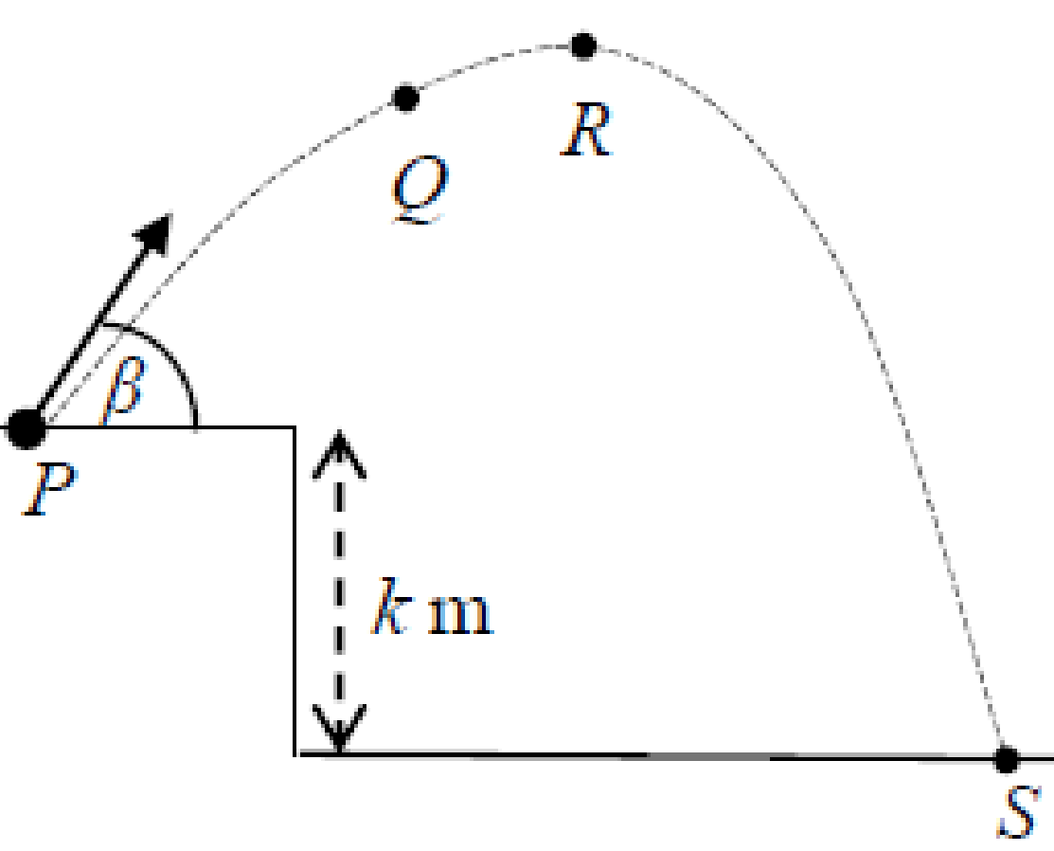
2016 OL
A particle is projected from a point P, as shown in the diagram, with an initial speed of 74 m s^{–1} at an angle β to the horizontal, where tan β = $\frac{35}{12}$.
The particle reaches point Q after 4 seconds of motion.
R is the highest point reached by the particle.
- Find the initial velocity of the particle in terms of i and j.
- Find the velocity of the particle at point Q in terms of i and j.
- Find the displacement of R from P in terms of i and j.
- Find the value of k, given that the particle reaches S after 16 seconds of motion.

2017 OL
A particle is projected from point P, as shown in the diagram, with initial speed 40√3 m s⁻¹ at an angle of 60° to the horizontal.
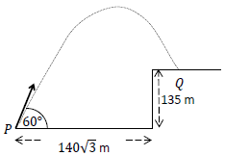
Find
- the initial velocity of the particle in terms of i and j.
- the velocity of the particle after 4 seconds of motion in terms of i and j.
- the greatest height of the particle.

The particle lands at point Q, which is on a vertical cliff of height 135 m.
The distance from P to the foot of the cliff is 140√3 m.
Find
- the time taken to travel from P to Q
- the time for which the particle is vertically above the cliff.

Target Practice – straightforward Higher Level

For Higher Level questions remember to take g = 9.8 m s⁻¹

2016 (a) HL
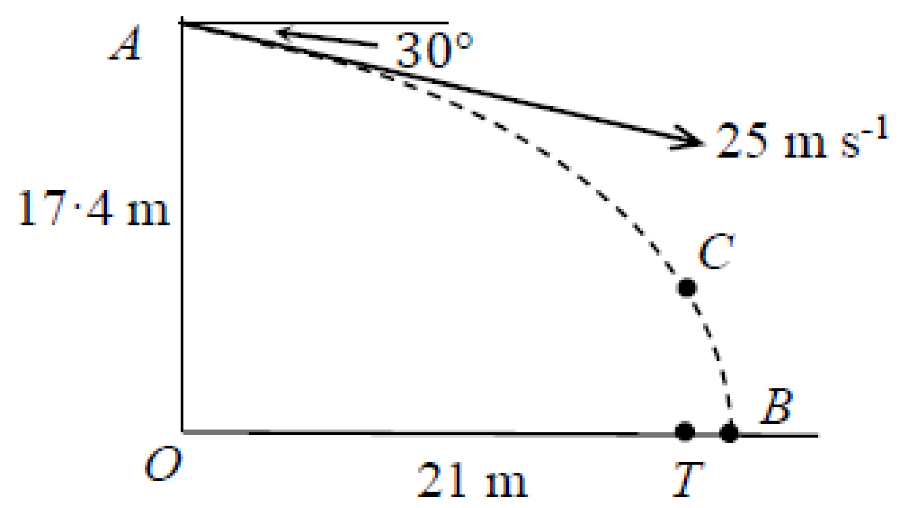
A ball is thrown from a point A at a target T, which is on horizontal ground.
The point A is 17·4 m vertically above the point O on the ground.
The ball is thrown from A with speed 25 m s^{–1} at an angle of 30° below the horizontal.
The distance OT is 21 m.
The ball misses the target and hits the ground at the point B, as shown in the diagram.
- Find the time taken for the ball to travel from A to B
- Find the distance TB.
- The point C is on the path of the ball vertically above T.
Find the speed of the ball at C.

1995 (a) HL
A ball kicked from a point p on level ground hit the ground for the first time 27 m from p after a time 3 s.
The ball just passed over a wall standing 5.4 m from p.
Find
- the horizontal and vertical components of its initial velocity.
- the height of the wall.
- the speed of the ball as it passed over the wall.

1994 (b) HL
A dart-player stood 3 m from a dart-board hanging on a vertical wall.
The dart is thrown horizontally from a point 1.8 m above the ground.
It strikes the board at a point 1.5 m above the ground.
Calculate
- the initial speed of the dart.
- the speed of the dart on striking the board.

Target Practice – tricky Higher Level

Now it gets trickier
Up until this point we have usually been able to get a value for t from one direction and sub this into the other direction.
Now we won’t have enough information to get a value for t, but instead we will end up with an expression for t in one direction and we then can proceed as before, substituting this into the other direction.
So the procedure is the very same, it’s just the algebra that gets a bit trickier.
(As an aside, rather than getting a value for t from one direction and subbing this into the other direction, sometimes it’s as handy to get a value for t from both directions and then equate these t values.)
How will you decide? Write out the basic equation for both situations and then compare and decide.

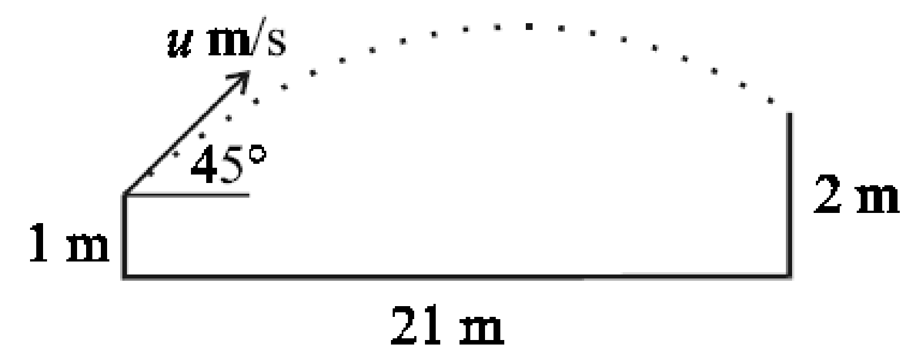
2001 (a)
A player hits a ball with an initial speed of u m/s from a height of 1 m at an angle of 45° to the horizontal ground.
A member of the opposing team, 21 m away, catches the ball at a height of 2 m above the ground.
Find the value of u.

Procedure for next three questions
At first glance these look very similar to the previous question, but solving the equations is more difficult because now we have t in term of α, which is where the trigonometric substitutions come in handy.

1998 (a)
A football is kicked from a spot on level ground with a velocity of 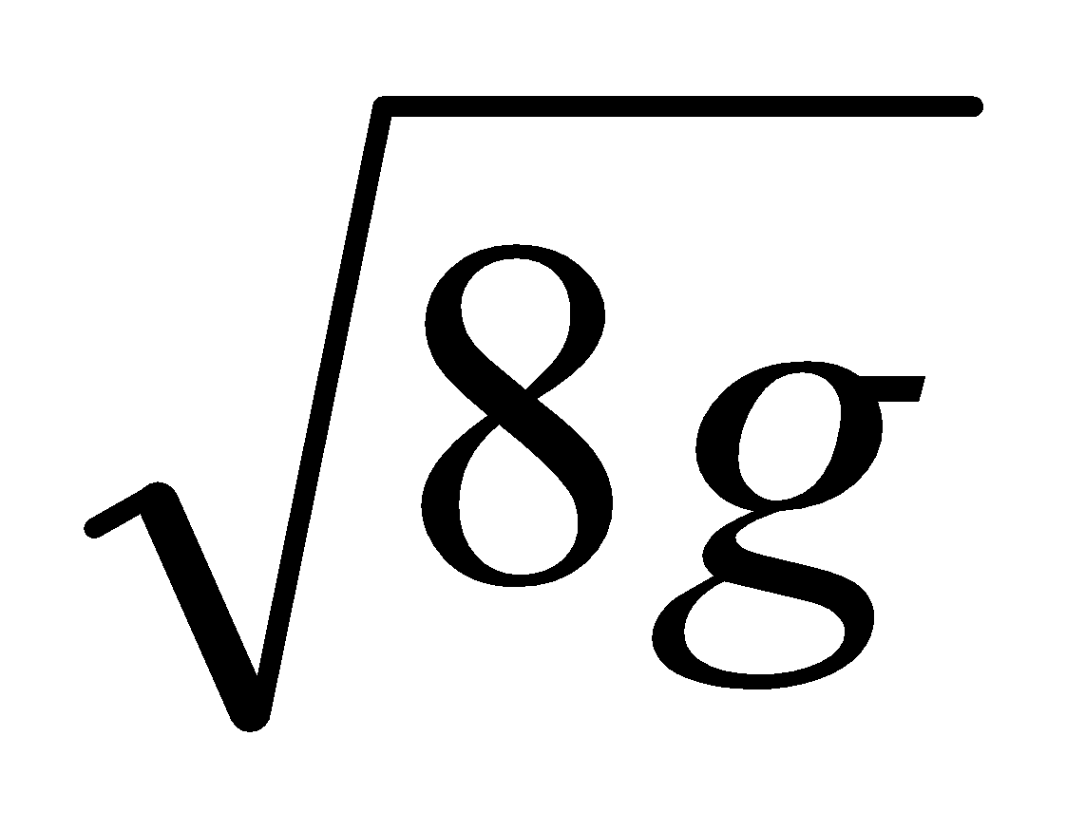m/s and strikes a vertical wall 4 m away at a point 2 m above the ground.
Find the two possible angles of projection.

1975
A missile is projected from a point o with speed 21 m/s at an angle α to the horizontal.
The missile strikes a small target whose horizontal and vertical distances from the point of projection are 30 m and 10 m respectively.
Find the two possible values of tan α, and the times taken on the corresponding trajectories.

1992
{part (ii) involves differentiation, so leave for now}
A particle is projected with velocity 6√g m/s, at an angle ⟨ to the horizontal, from a point 18 m in front of a vertical wall 5.5 m high.
- Calculate the two possible values of ⟨ which will enable the particle to just clear the wall.
- Show that the value of ⟨ is tan⁻¹2 for maximum clearance height.

General questions

Displacement – notation:
A position vector is often represented by r.
Its position is given relative to a specific origin (to use the fancy lingo - “it is not a free vector”).

1997 (a)
A golf ball, at rest on the horizontal ground, is struck so that it starts to move with velocity 3u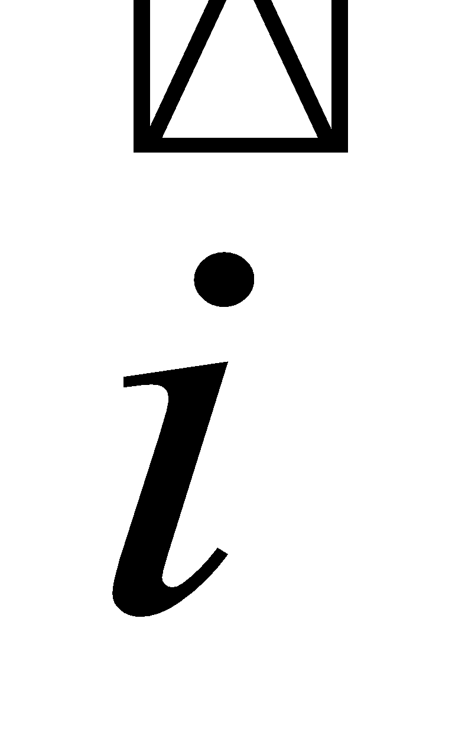 + u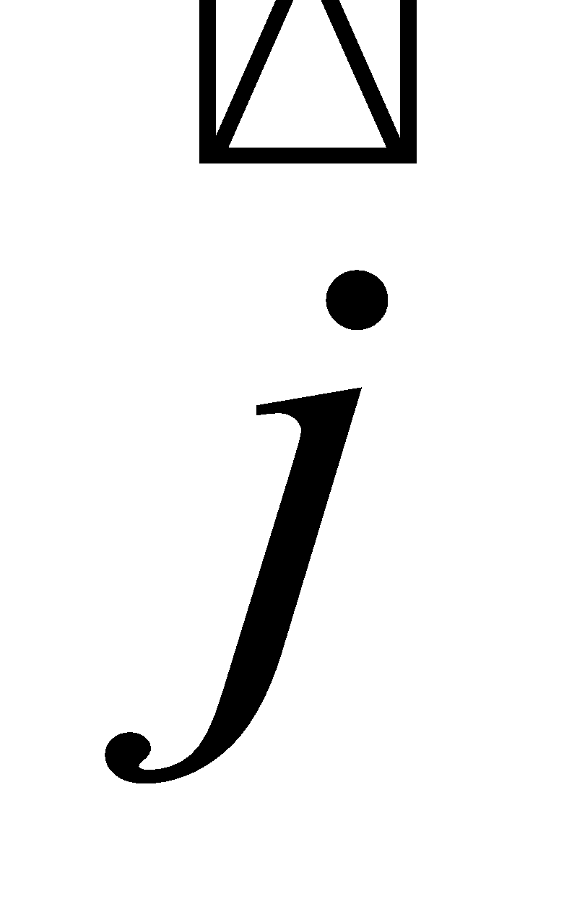 where and are unit vectors along and perpendicular to the ground, respectively.
In its flight the ball rises to a maximum height of 15 m.
Calculate
- the value of u,
- the magnitude and direction of the velocity with which the ball strikes the ground.

1994 (a)
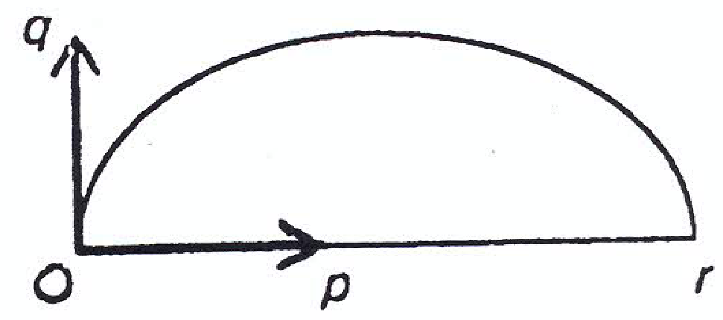
A ball is kicked from level ground. The first bounce occurs at the point r, 45 m from the kicking point O and the greatest height reached was 22.5 m.
If the horizontal and vertical components of the initial velocity are taken as p and q as in the diagram, calculate
- the value of p and the value of q.
- the farthest distance from r that a person running at 7 m/s can be, so that starting when the ball was kicked, the person can be at r just as the ball lands.

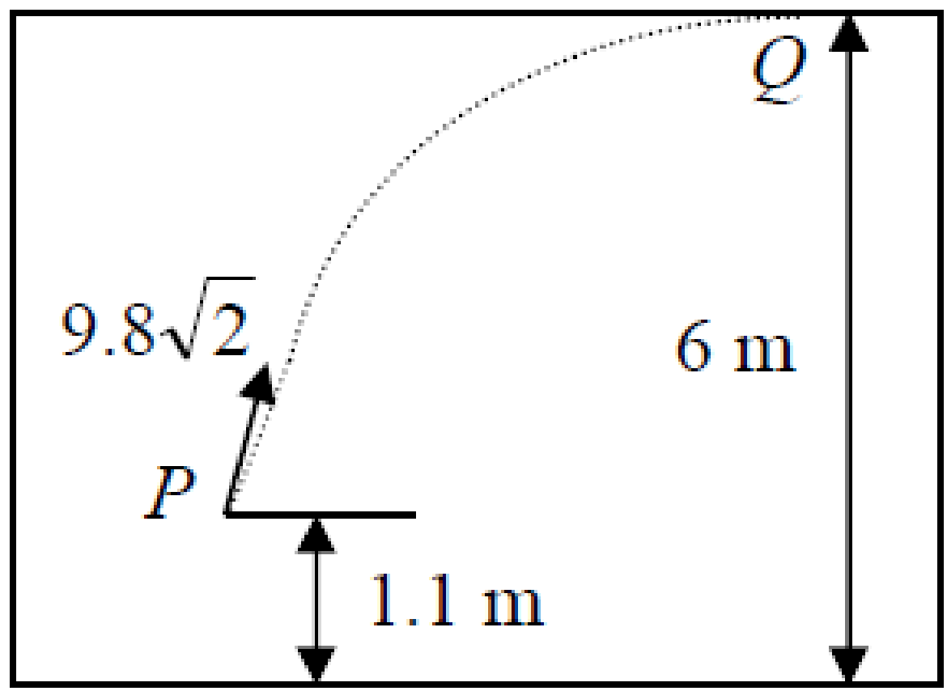
2010 (a)
In a room of height 6 m, a ball is projected from a point P.
P is 1.1 m above the floor.
The velocity of projection is 9.8√2 m s⁻¹ at an angle of 45⁰ to the horizontal.
The ball strikes the ceiling at Q without first striking a wall.
Find the length of the straight line PQ.

2022 Deferred (a)
A particle is projected from a point on horizontal ground.
The speed of projection is 14 m s⁻¹ at an angle 𝛼 to the horizontal.
Find the two values of 𝛼 that will give a range of 10 m.

2022 (a)
A particle is projected out to sea from a point P on a cliff to hit a target 60 m horizontally from P and 60 m vertically below P.
The velocity of projection is 14√3 m s^{–1} at an angle 𝛼 to the horizontal.
Find
- the two possible values of 𝛼
- the times of flight.

2018 (a)
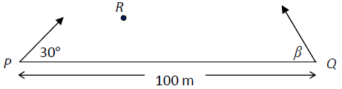
A particle is projected from a point P with speed 60 m s^{–1} at an angle of 30° to the horizontal. At the same time a second particle is projected from a point Q with speed 50 m s^{–1} at an angle β to the horizontal.
P and Q are on the same horizontal level and are 100 m apart.
The particles collide at R as shown in the diagram.
- Show that sin β = $\frac{3}{5}$.
- Find the distance |PR|.

2019 (a)
A particle is projected with speed 40 m s^{–1} from a point A on the top of a vertical cliff of height 30 m.
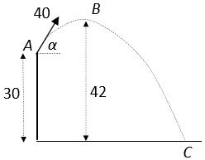
The maximum height reached by the particle is 42 m above the horizontal ground, at point B.
It strikes the ground at C.
Find
- the value of 𝛼, the angle of projection
- the horizontal range of the particle
- the speed of the particle as it hits the ground at C.

~~~~~~Brief introduction to slightly trickier questions~~~~~

2007 (a)
A particle is projected with a speed of $7\sqrt{5}$ m/s at an angle α to the horizontal.
Find the two values of α that will give a range of 12.5 m.
This is the first time you need to extend your algebra.
Use S_{y}= 0 to get an expression for t. Now sub this into the expression for S_{x} and solve.
Along the way you will need to use the fact that 2cos α sin $α$ = sin 2α
The first time you do this question just find one angle of projection (to find the second angle you must invoke the CAST rule).

1988 (a)
A particle which is projected with speed u has a horizontal range $\frac{3u^{2}}{49}$.
Calculate the two possible angles of projection.
2012 (a)
A particle is projected with a speed of 98 m s⁻¹ at an angle α to the horizontal.
The range of the particle is 940·8 m. Find
- the two values of α
- the difference between the two times of flight.

2013 (a) {nice question – part (ii) could be left as an extension question in fifth year, or else until sixth year}
A particle is projected from a point on horizontal ground.
The speed of projection is u m s⁻¹ at an angle α to the horizontal.
The range of the particle is R and the maximum height reached by the particle is$\frac{R}{4\sqrt{3}}$.
- Show that $R=\frac{2u^{2}sin αcos α }{g}$.

- Find the value of $α$

2020 (a)
A particle is projected from a point P with speed u m s^{–1} at an angle α to the horizontal.
- Show that the range of the particle is $\frac{2u^{2}\sin{α\cos{α}} }{g}$

- The particle is 24.5 m above the horizontal ground after 5 seconds and it strikes the ground 235.2 m from P.
Find the value of u.

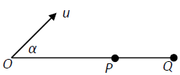
2021 (a)
A particle is projected from a point O with speed u m s^{–1} at an angle α to the horizontal.
- Show that the range of the particle is $\frac{u^{2}sin 2α }{g}$,
and that the maximum range ∣OQ∣ is $\frac{u^{2}}{g}$ .

- If the angle of projection is increased to 60° the particle strikes the horizontal plane at P.
Find the distance ∣PQ∣ in terms of u.

1970 (a)
A particle is projected under gravity with an initial velocity u at an angle θ to the horizontal.
Find its position after time t in terms of u, θ, g and t.

1987 (b)
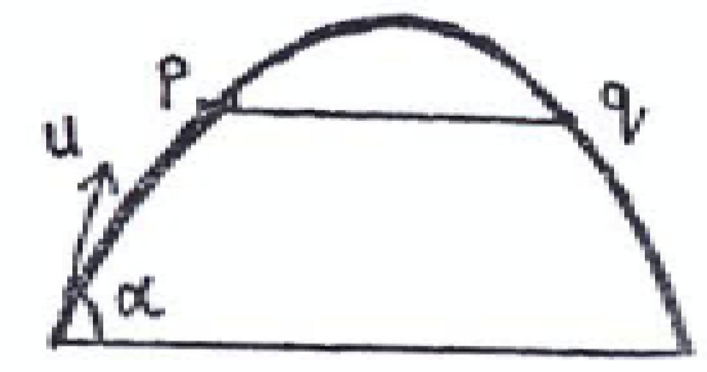
{There is a ridiculously short and a ridiculously long way to do this.
If you’re taking more than 2 lines then you’re on the long road}
A particle is projected with speed u at an angle to the horizontal.
The particle takes 4 s to travel between two points p and q which are on the same horizontal line.
Show that the greatest height the particle reaches above this line is 19.6 m.

2004 (a) {straightforward question – careful with algebra}
{There is a short and a long way to do this one also.}
A particle is projected from a point on the horizontal floor of a tunnel with maximum height of 8 m.
The particle is projected with an initial speed of 20 m/s inclined at an angle α to the horizontal floor.
Find, to the nearest meter, the greatest range which can be attained in the tunnel.

2009 (a)
{Algebra a little tricky. Just set it up in fifth year and solve in sixth year. Note that [$\frac{1}{\cos^{2 }α}= 1+\tan^{2}α]$}
A straight vertical cliff is 200 m high.
A particle is projected from the top of the cliff.
The speed of projection is $14\sqrt{10}$ m/s at an angle α to the horizontal.
The particle strikes the level ground at a distance of 200 m from the foot of the cliff.
- Find, in terms of α, the time taken for the particle to hit the ground.
- Show that the two possible directions of projection are at right angles to each other.

2003 (a) {nice question – but best left as an extension question in fifth year, or else until sixth year}
A particle is projected from a point on level horizontal ground at an angle θ to the horizontal ground.
Find θ, if the horizontal range of the particle is five times the maximum height reached by the particle.

1993 (a) {similar to the previous question}
A particle is projected on a horizontal plane with initial velocity u at an angle β to the horizontal.
If the range of the projectile is three times the greatest height, prove that tan β = ⁴/₃.

1986
{part (i) is similar to the two previous questions, parts (ii) and (ii) definitely best left to sixth year}
A particle is projected with speed u at an angle ⟨ to the horizontal.
- If the maximum height reached is the same as the total horizontal range, show that tan ⟨ = 4.

- The particle moves at right angles to its original direction of motion after a time t₁ and then strikes the horizontal plane after 8 s, both times measured from the instant of projection.
Show $u=g\sqrt{17}$
- Calculate t₁.

2002 (a) {not too bad, but algebra is a little tricky so leave until sixth year}
A particle is projected from a point on the horizontal ground with a speed of 39.2 m/s inclined at an angle α to the horizontal ground. The particle is at a height of 14.7 m above the horizontal ground at times t₁ and t₂ seconds, respectively.
- Show that t₂ – t₁ = 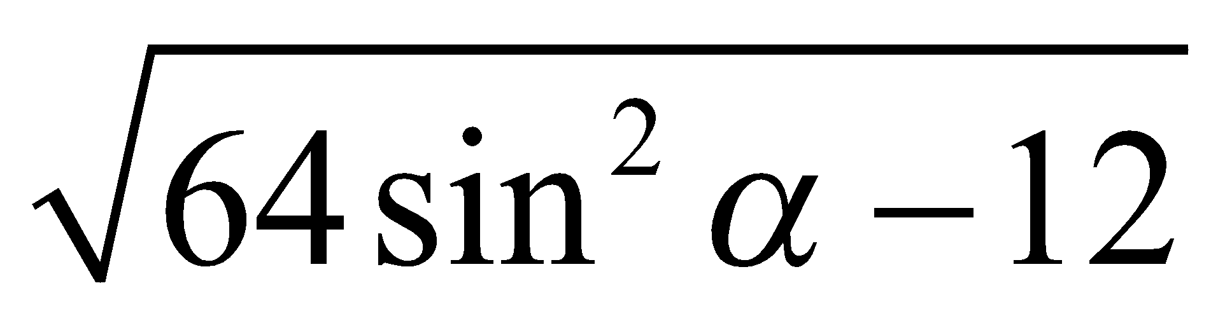
- Find the value of α for which t₂ - t₁ = 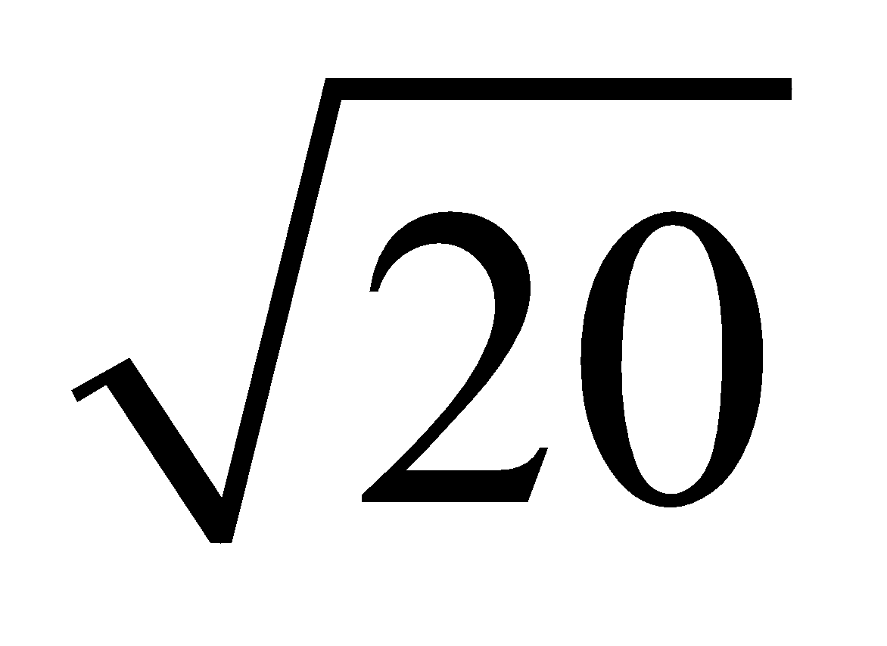.

2014 (a) {quite similar to 2002 (a), but leave until sixth year}
A particle is projected from a point on the horizontal ground with speed u m s^{–1} at an angle 30° to the horizontal. The particle is at a height of 7.35 m above the horizontal ground at times t₁ and t₂ seconds.
If t₂ - t₁ = 1.5 seconds, find the value of u.

2015 (a)
A tennis player, standing at P, serves a tennis ball from a height of 3 m to strike the court at Q.
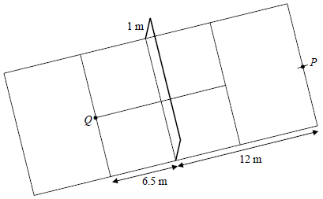
The speed of serve is 50 m s^{–1} at an angle β to the horizontal.

- Find the two possible values of tan β.
- For each value of tan β find the time, t, it takes the ball to reach Q.
- If the tennis player chooses the smaller value of t, by what distance does the ball clear the net?

1996 (a) {not too bad, might be able to do it in fifth year}
A particle is projected from the ground with a velocity of 50.96 m/s at an angle tan⁻¹ $\frac{5}{12}$ to the horizontal.
On its upward path it just passes over a wall 14.7 m high.
During its flight it also passes over a second wall 18.375 m high.
Show that the second wall must be not less than 23.52 m and not more than 70.56 m from the first wall.

2011 (a)
{just do part (i) first time around. Part (ii) involves some tricky algebra / trigonometry substitutions}
A particle is projected from a point P on horizontal ground.
The speed of projection is 35 m s⁻¹ at an angle tan⁻¹ 2 to the horizontal.
The particle strikes a target whose position vector relative to P is x i+50 j
Find
- the value of x
- a second angle of projection so that the particle strikes the target.

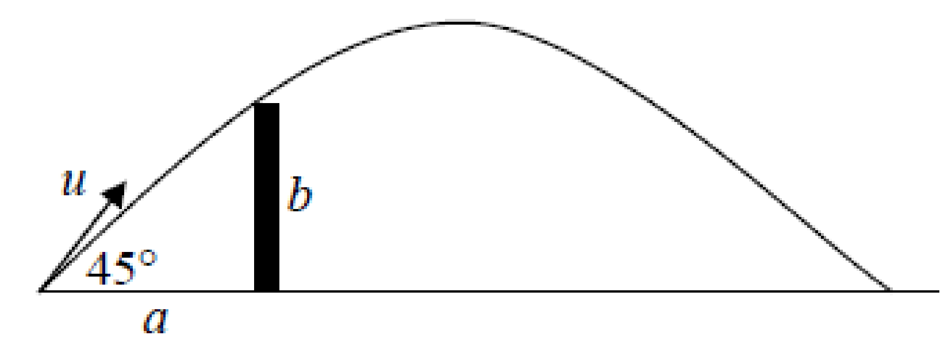
2008 (a) {leave for sixth year}
A ball is projected from a point on the ground at a distance of a from the foot of a vertical wall of height b, the velocity of projection being u at an angle 45° to the horizontal.

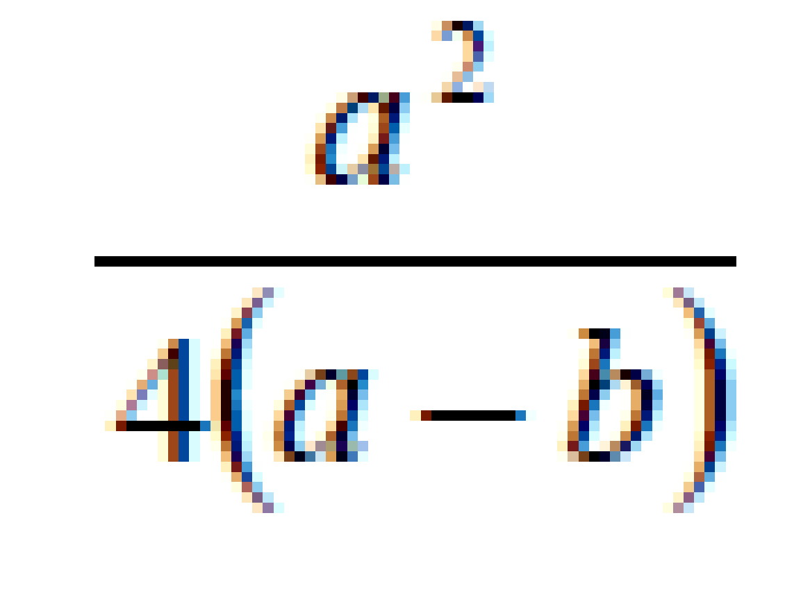
If the ball just clears the wall prove that the greatest height reached is

Some very difficult questions: as a final revision only

2017 (a)
A particle is projected with speed $\frac{\sqrt{9gh}}{2}$ from a point P on the top of a cliff of height ℎ.
It strikes the ground a horizontal distance 3ℎ from P.
- Find the two possible angles of projection.
- For each angle of projection find, in terms of ℎ, the time it takes the particle to reach P.
{Note: Part (ii) should have asked to find the time taken for the particle to reache the ground (not P), so marks were awarded for any attempt on this section, but to get full marks you had to answer the question as asked.}

2006 (a) {very difficult – definitely sixth year}
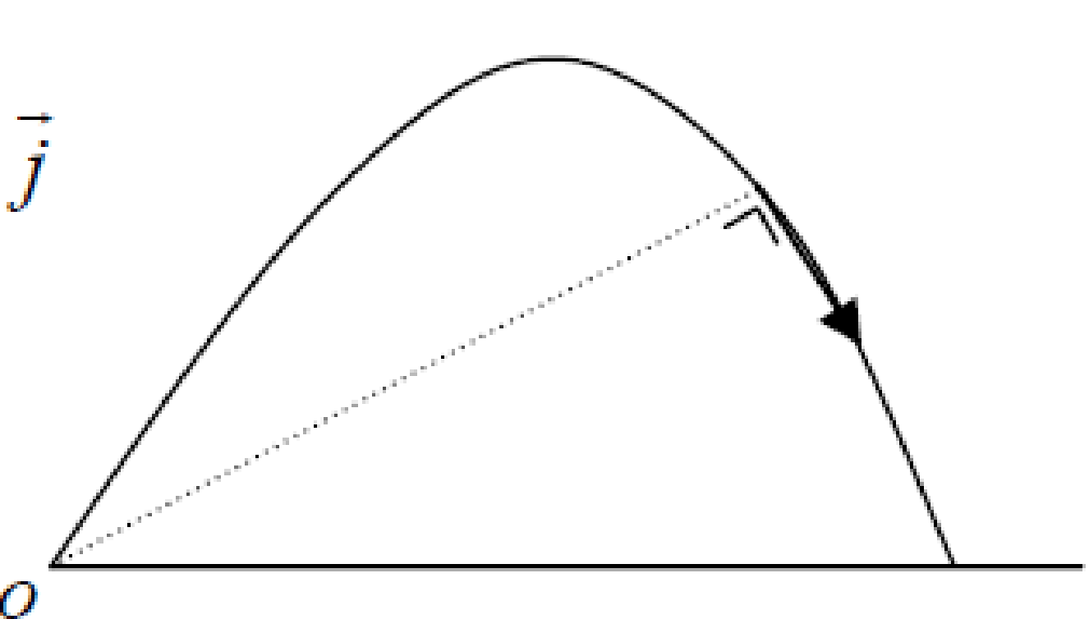
A particle is projected from a point o with velocity 9.8i + 29.4j where i and j are unit perpendicular vectors in the horizontal and vertical directions, respectively.
- Express the velocity and displacement of the particle after t seconds in terms of i and j.
- Find, in terms of t, the direction in which the particle is moving after t seconds.
- Find the two times when the direction of the particle is at right angles to the line joining the particle to o.

1981 (b) {very difficult – definitely sixth year}
A particle is projected at initial speed u from the top of a cliff of height h, the trajectory being out to sea in a plane perpendicular to the cliff.
The particle strikes the sea at a distance d from the foot of the cliff.
- Show that the possible times of flight can be obtained from the equation

g²t⁴ – 4(u² + gh)t² + 4(h² + d²) = 0.
- Hence or otherwise, prove that the maximum value of d for a particular u and h is 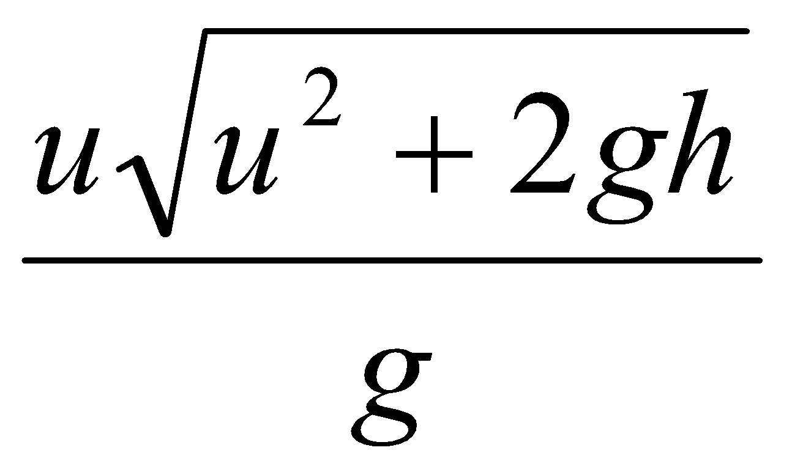

1972
From a point p on horizontal ground an elastic particle is projected under gravity with a velocity of 28 + 21 m/s, where and are unit vectors along the horizontal and upwards drawn vertical, respectively. Find the displacement 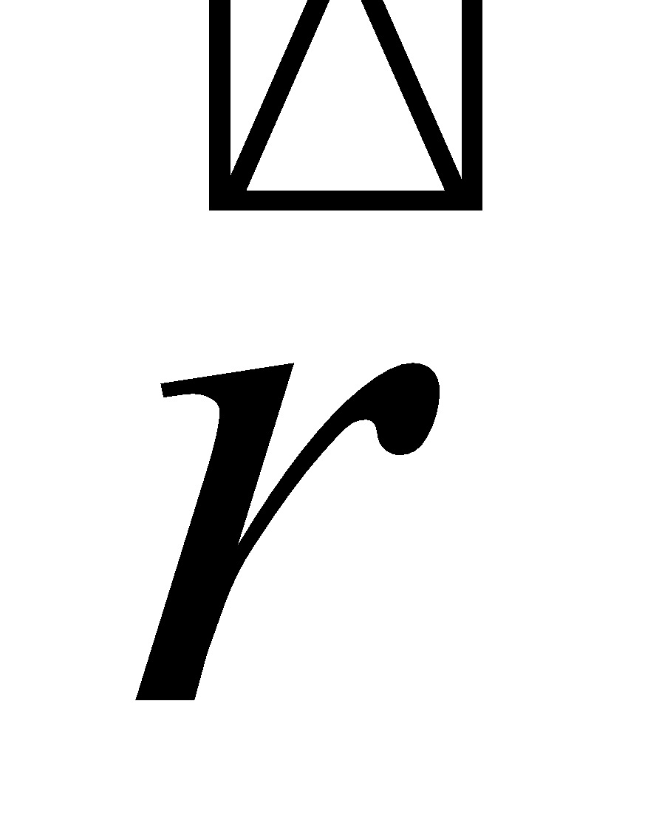 from p at any time t seconds after and in particular when the particle is at it highest point.
If at this point the particle strikes a fixed vertical wall, where the coefficient of restitution is ½, find how far from p the particle strikes the ground.

1983
A bullet is fired from a gun fixed at a point o with speed v m/s at an angle of θ to the horizontal.
At the instant of firing, a moving target is 10 m vertically above o and travelling with a constant speed
42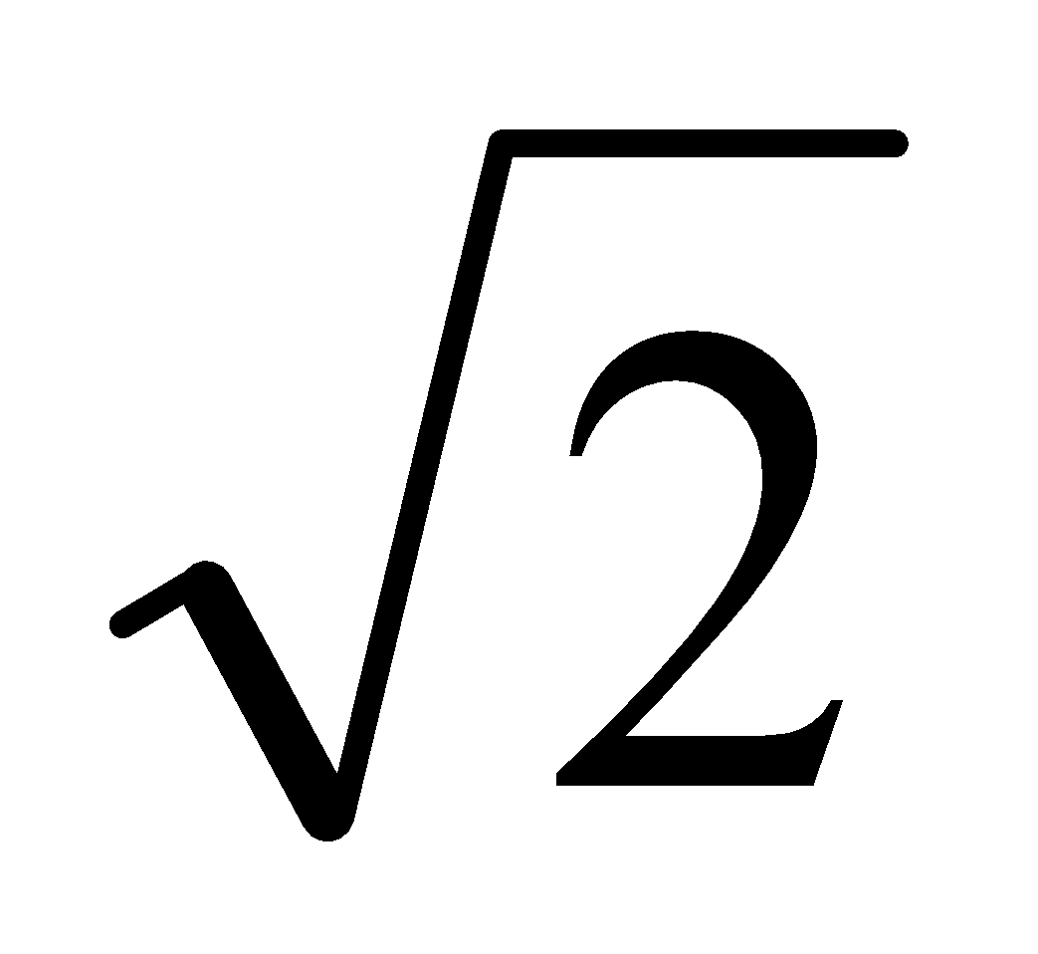 m/s at an angle of 45⁰ to the horizontal.
The bullet and target move in the same plane.
- If v = 70 m/s and tan θ = ⁴/₃, find at what time after firing does the bullet strike the target and calculate the horizontal distance of the bullet from o.
- Show that the minimum value of θ to ensure that the bullet strikes the target is given by tan θ = ⁴/₃
1970 (b)
A particle is projected from the top of a cliff which is 425 ft. above sea level and the angle of projection is 45⁰ to the horizontal.
If the greatest height reached above the point of projection is 200 ft, find the speed of the projection and the time taken to reach this greatest height.
Find when and where the particle strikes the sea.
(Take g to be 32 ft/sec².)

Maximum Range

Do as you would in maths when asked to find the maximum or minimum point on a curve; differentiate the expression (with respect to the angle), then let dR/dϑ = 0 to find ϑ.

2000 (a)
A particle is projected with a velocity of u m/s at an angle β to the horizontal ground.
Show that the particle hits the ground at a distance 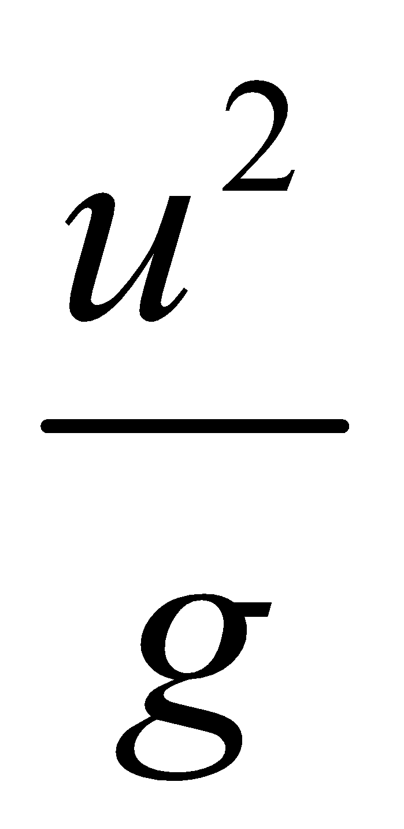β from the point of projection.
Find the angle of projection which gives maximum range.

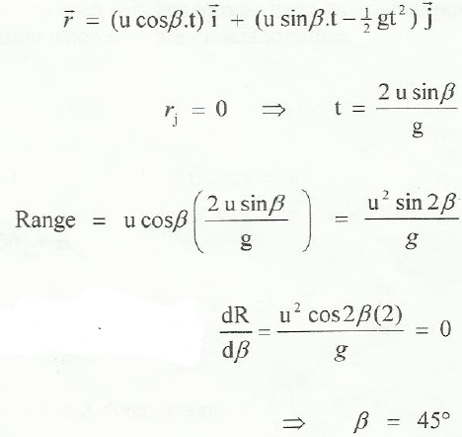
Solution:

OR
Note that $\frac{u^{2}sinsin 2β }{g}$
Now the maximum value that sin 2β can be is 1; this will happen if 2β is 90⁰, or β = 45⁰.
And that’s it.

However the expression for the range won’t always be in the form above, so you need to be familiar with the differentiation method.

1981 (a)
Establish an expression, in terms of initial speed u and angle of inclination to the horizontal α, for the range of a projectile on a horizontal plane through the point of projection.
Deduce that the maximum range for a given u is u²/g.

1989
A particle is projected with speed u at an angle α to the horizontal.
The range of the particle on the horizontal plane through the point of projection is R.
- Show that R is a maximum when α = 45⁰.
- If R =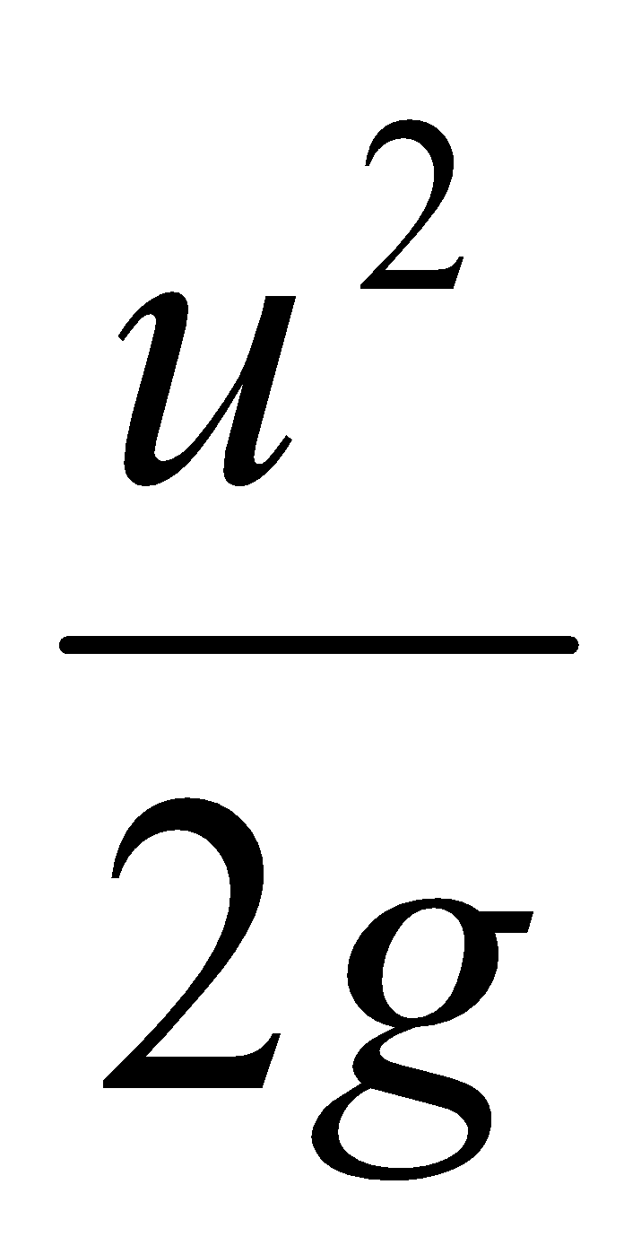 , find the two possible values of α.
- If the ratio of the greatest height to the range is 2:5, find α.

Trickier example
Given the expression for the range in the first line below, we can find the value of ϑ that would result in maximum range as follows:
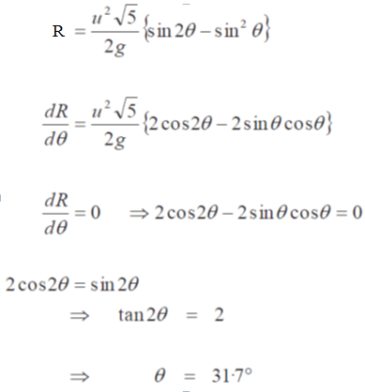

Combining Collisions with Projectiles

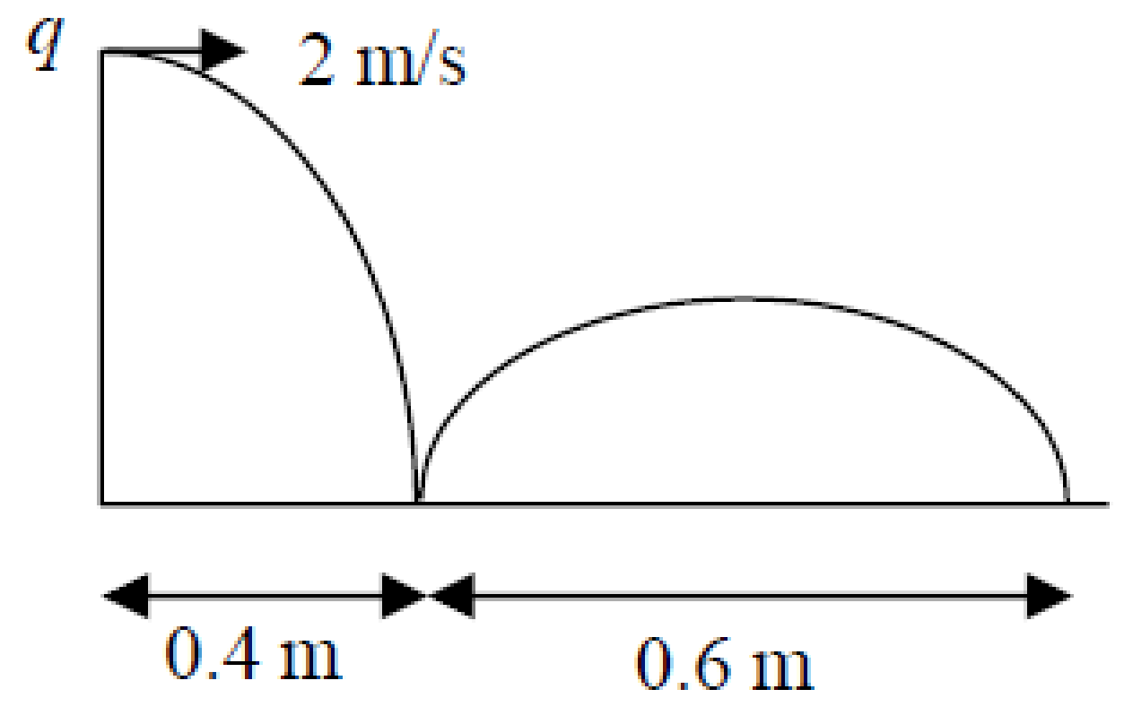
2005 (a)
A ball is projected horizontally from a point q above a smooth horizontal plane with speed 2 m/s.
The ball first hits the plane at a point whose horizontal displacement from q is 0.4 m.
The ball next strikes the plane at a horizontal displacement of 1 m from q.
The coefficient of restitution between the ball and the plane is e.
Find the value of e.

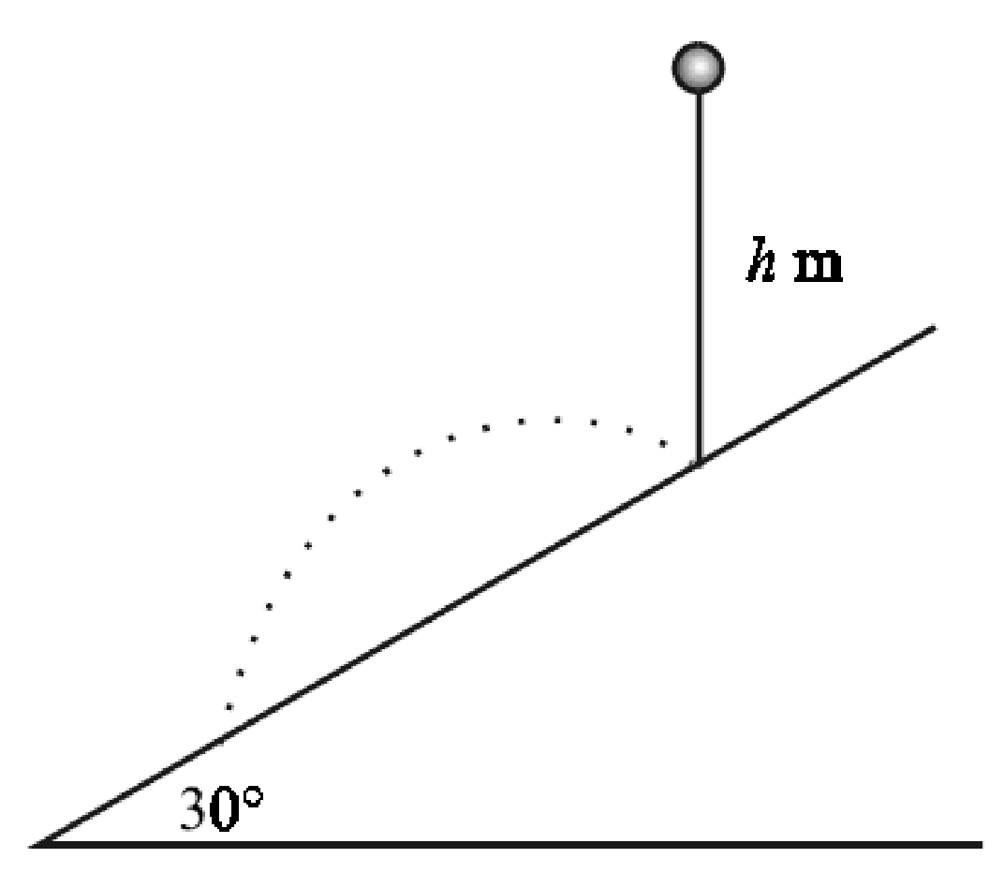
2001 (b)
A ball is dropped from a height of h m onto a smooth inclined plane. The ball strikes the plane at p and rebounds.
The plane is inclined at an angle of 30° to the horizontal and the coefficient of restitution between the ball and the plane is ½.
Find how far down the plane from p is the ball's next point of impact.
Express your answer in terms of h.

Answers to ordinary level exam questions
2017
- u = 20√3 i + 60 j
- v = 20√3 i + 20 j
- Greatest height = 180 m
- t = 9 s
- t = 2 s

2016
- v = 24 i + 70 j
- v = 24 i + 30 j
- v = 168 i + 245 j
- k = 160 m

2015
(a)
- d = 56 m
(b)
- v = 21 i + 20 j
- v = 29 m s⁻¹, α = 43.6⁰
- t = 9 s, k = 135

2014
- v = 18 i + 80 j
- t = 8 s
- distance = 320 m
- range = 288 m
- t = 5 s, t = 11 s.

2013
- t = 2 s
- height = 45 m
- t = 5 s
- ⏐AB⏐= 75 m
- v = 15√5 m s⁻¹

2012 (a)
- t = 2√2 s
- ⏐PQ⏐= 40 m

2012 (b)
- v = 21 i + 20 j
- v = 29 m s⁻¹, α = 43.6⁰
- t = 8 s, k = 168

2011
- v = 42 i + 40 j
- t = 4 s
- distance = 80 m
- range = 336 m
- t = 3 s, t = 5 s.

2010
- t = 3 s
- distance = 80 m
- t = 7 s
- ⏐OP⏐= 504 m
- v = 82.4 m s⁻¹

2009 (a)
- v = 40 i + 30 j
- Speed = 50 m s⁻¹, ⎝ = 36.87⁰
- k = 45

2009 (b)
x = 17.3

2008
- v = 15 i + 20 j
- t = 2 s
- s = 20 m
- range = 60 m
- speed = 18.0 m s⁻¹, ⎝ = 33.69⁰

2007
- t = 1 s
- Max height = 45 m
- t = 3 s
- Range = 56 m
- Speed = 33.11 m s⁻¹

2006
- t = 3.5 s
- maximum height = 61.25 m
- t = 2 s and t = 5 s
- Speed = 36.4 m s⁻¹

2005 (a)
- = 60⁰
- ⏐op⏐= 650 m

2005 (b)
u = 129.9 m s⁻¹

2004 (a)
- u = 4 m s⁻¹
- h = 1 m

2004 (b)
⎝= 45⁰

2003
- Initial velocity = 40 i + 30 j

- 5 m
- Speed = 41 m s⁻¹
2002
- t = 4 s
- x = 20 m s⁻¹

- Range = 60 m

2001
- t = 3 s
- Distance = 60 m
- y = 22.5 m

2000 (a)
S = 45 m
T = 6 s
⏐pq⏐= 240 m

Guide to answering higher level exam questions

TO BE UPDATED

2010 (a)
Straightforward. Use Sy = 4.9 to get t = 1, then sub this into Sx to get Sx = 9.8 m.
Then use Pythagoras to get⏐PQ⏐ = 10.96 m

2010 (b)
- The particle strikes the plane at an angle of tan⁻¹ (2/√3). Let Sy = 0 to get a value for t, then sub into Vy and Vx.
Then use Tan ⎝ = -Vy/Vx = 2/√3
Answer: ⎝ = 23.4⁰.
- Straightforward. Use the magnitude formula to get v = 52.9 m s⁻¹.

2009 (a)
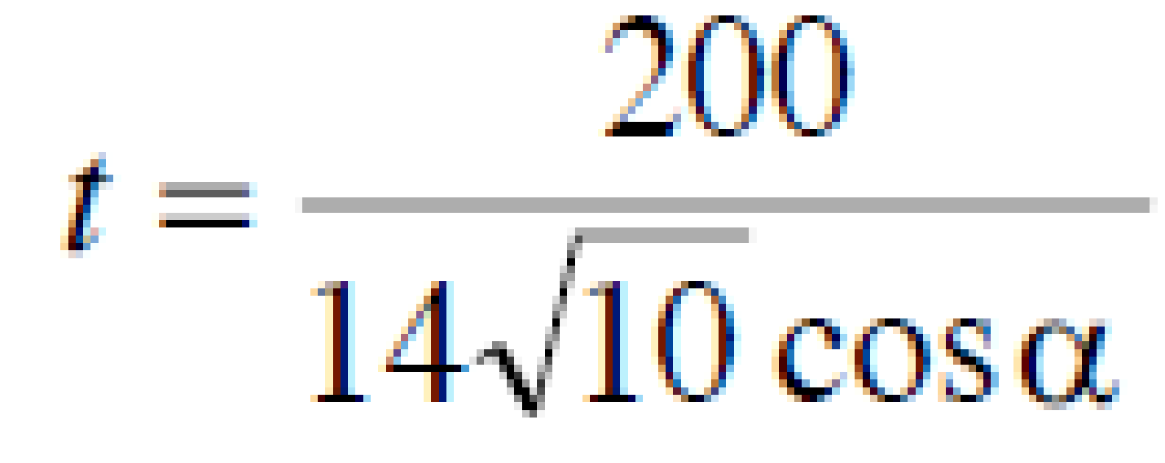
- Straightforward if you use s_{x} = 200 (using s_{y} = -200 would involve t² and therefore would be trickier. Answer:

- Nasty. It should be obvious that to get two answers you need a quadratic, and this you can get from using s_{y} = -200. Angle of projection corresponds to tan ⟨, and from the quadratic you get two expressions for tan ⟨. Multiply these out to get -1, which verifies that the directions are perpendicular.

2009 (b)
Straightforward. Use v_{x} = 0 to get one value for t, and s_{y} = 0 to get another. Equate the values for t and solve to get the required expression.

2008 (a)
This is a ‘Target question’.
Get expression for S_{x} and let it equal a, then get expression for S_{y} and let it equal b. Get t on its own from S_{x} = a equation and sub this into S_{y} = b.
Use this to get an expression for u², then set this aside for later.
Now use your normal approach for ‘greatest height’; let V_{y} = 0 to get an expression for t, then sub this into the expression for S_{y} and when you find that you have a u², just sub in the expression which you got at the beginning.

2008 (b)
Range: Straightforward, but there is a bit of playing with trigonometric expressions.
Note that {cos 2⎝ sin⎝ + 2 sin⎝ sin²⎝} becomes {(cos²⎝ - sin²⎝)sin⎝ + 2sin³⎝}
Ans: k = 4

2007 (a)
Straightforward, but note that if sin 2⟨ is ½, then 2⟨ = 30⁰ or 150⁰.
Ans: ⟨ = 15⁰ and 75⁰.

2007 (b)
Straightforward, see the key that corresponds to the phrase: “the particle is moving horizontally when it strikes the inclined plane”.

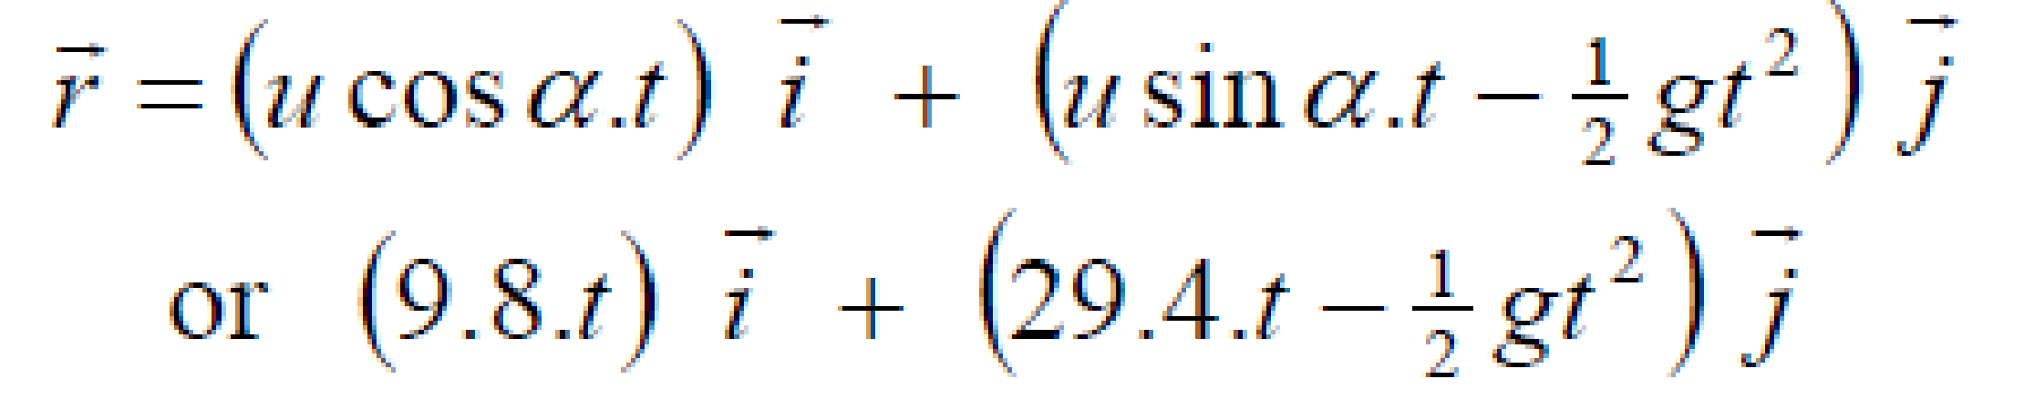
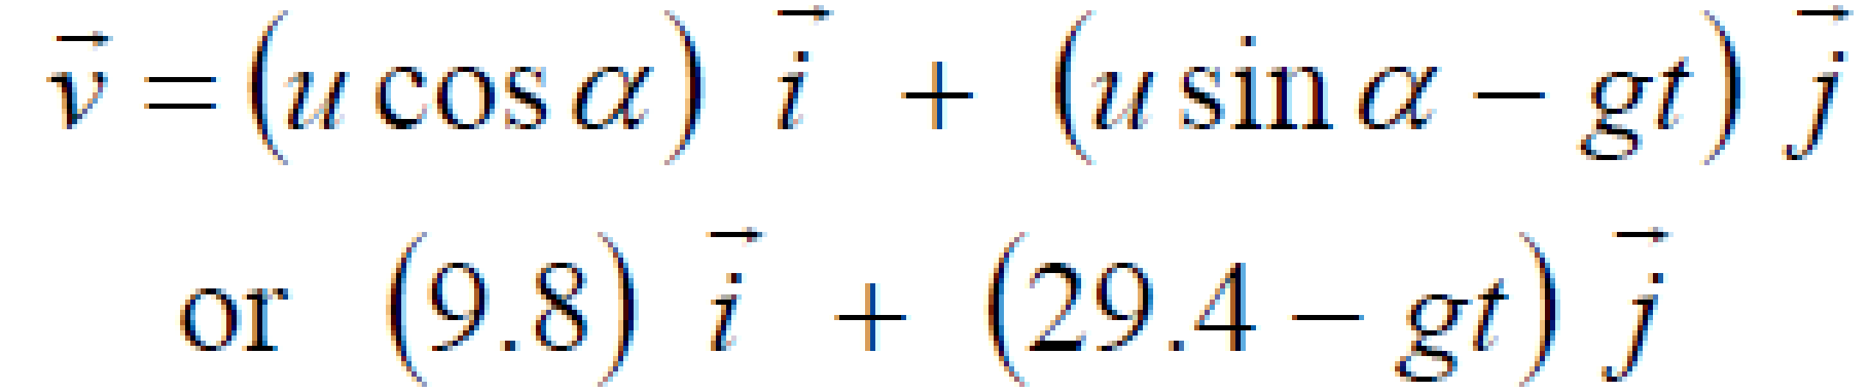
2006 (a)
- Straightforward
Ans:

- Straightforward (tan ⎝ = v_{y}/v_{x})
Ans: Direction = 3-t
- This one is quite tricky: “Find the two times when the direction of the particle is at right angles to the line joining the particle to o”.
The phrase “the direction of the particle” should read “the direction in which the particle is moving”, which we have already worked out from part (ii) as being 3-t.
The phrase “the line joining the particle to o” should read “ the line joining the position of the particle to o”; the slope of this line corresponds to the inverse tan of S_{y}/S_{x}.
If both lines are perpendicular then the products of these two slopes equals -1.
Ans: t = 4 s and t = 5 s.

2006 (b)
Easy peasy.
Ans: Range = 2u²/3g

2005 (a)
Okay, but it does combine projectiles with a concept from collisions.
Note that the ball is projected horizontally so U_{x} = 2 and U_{y} = 0.
Use this information to get the initial velocity for the second stage (U_{y} here will be in terms of e).
Ans: e = ¾.

2005 (b)
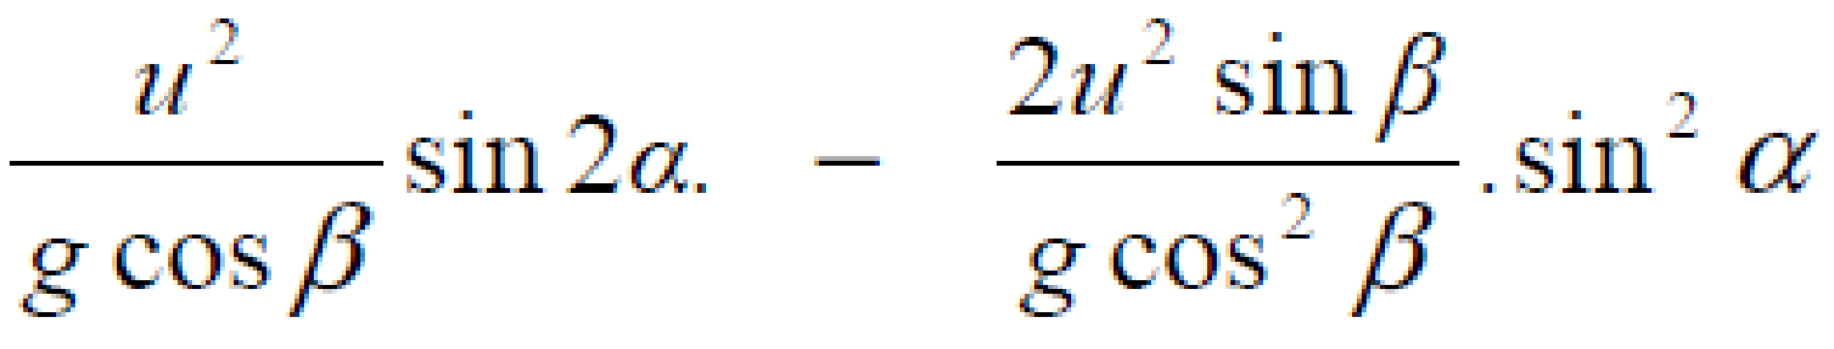
- Straightforward except that it seem that the final expression is a bit unwieldy and you might be tempted to spend a bit of time playing with trigonometric expressions to tidy things up when in fact this gets you nowhere.
Ans: Range =

- Remember that for maximum range you will need to differentiate the expression for the range in terms of ⟨, and then let this = 0, i.e. dR/d⟨ = 0.

2004 (a)
For greatest range the projectile would pass through the highest point of the tunnel, i.e. S_{y} = 8 when V_{y} = 0. Solve to find t and ⟨.
Ans: Greatest range = 40 m.

2004 (b)
Straightforward, see the key that corresponds to the phrase “the particle strikes the inclined plane at right angles”.

2003 (a)
Straightforward: Use S_{y} = 0 to get an expression for t.
Sub into expression for range, and sub t/2 into expression for maximum height.
Then use the equation: Range = 5 (Maximum height).
Ans: ⎝ = 38.7⁰

2003 (b)
Straightforward in principle, but there is a bit of playing with trigonometric expressions. In fact this was so messy that the marking scheme indicates that full marks were allocated for corrected substitution without any further simplification.
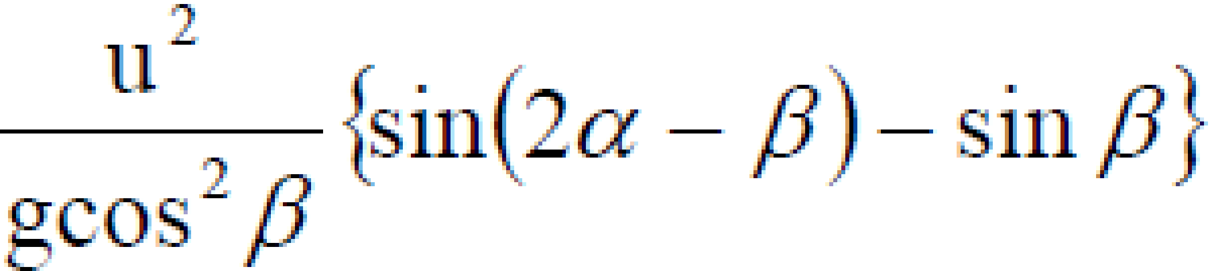
Ans: Range =

2002 (a)
- Straightforward, note that when you use S_{y} = 14.7, you end up with a quadratic and therefore two answers for t. It’s still a little tricky to get the final expression, but you can do it!
- Easy peasy. Ans: ⟨ = 45⁰.

2002 (b)
- Straightforward, see the key that corresponds to the phrase “the particle strikes the inclined plane at right angles”.
- Straightforward, use the previous expression to get a value for tan β, then draw a small right-angled triangle to get values for cos β and sin β. Sub these into the expression for range to obtain the required expression.

2001 (a)
Straightforward example of a ‘Target question’: S_{y} = 1 when S_{x} = 21.
Ans: u = 14.7 m s⁻¹.

2001 (b)
Not too bad, but it does combine Projectiles with Collisions.
There are two stages; use equations of motion to find the particle’s velocity just before it hits the plane, break this up into the i and j direction. Multiply the j-component by – e to get U_{y} for stage two. U_{x} for stage 2 will be the same as V_{x} from stage one.
Ans: S_{x} = 3h/2.

2000 (a)
Straightforward. Two (slightly) tricky bits. Note that 2 sin® cos® = sin 2® /2 to get range = u²sin 2® /g
Now for this expression to be a maximum the sin 2® bit must be a max. The maximum value for sin 2® is 1 and this only happen if 2® = 90⁰.
Answer: ® = 45⁰.

2000 (b)
Mostly straightforward, but the tricky bit is in bold. The angle between projection and slope is (⟨ - ⎝). The particle strikes the plane at right angles means s_{y} = 0 when v_{x} = 0, so get a value for t from both expressions and equate.
You also need to use log tables to split tan (⟨ - ⎝) into tan ⟨ and tan ⎝.
Answer: ⎝ = 26.6⁰ and ⎝ = 45⁰.

1999
(a)
Mostly straightforward, the particle is moving horizontally therefore use Sy = 0 to get a value for t, then sub into tan ⎝ = -Vy/Vx.
Answer: ⎝ = 26.5⁰ and ⎝ = 45⁰
(b)
- Okay; if tan ⎝ = 0.5 then use this to get sin ⎝ and cos ⎝, and use this to calculate t (t = 4 seconds). Now you can calculate Vy and Vx and from this the magnitude.
Answer: Magnitude = 4g
- Straightforward. There is kinetic energy at p and kinetic plus potential energy at q.
Answer: Total energy at p = 16 mg² = total energy at q.

1998 (a)
Straightforward. Sx = 4 when Sy = 2, so use Sx = 4 to get a value for t and sub this into Sy = 2.
Answer:
⟨ = 45⁰ and 71.33⁰

1998 (b)
Note that the particle is projected downwards so the component of g in the x direction is positive.
- Straightforward. Use t = 2 and sub into Sy = 0.
Answer: ⟨ = 44.43⁰.
- Straightforward. Use tan (landing angle) = -Vy/Vx, and set this equal to 1/3.
The algebra does get a little tricky here also.
Answer: ⟨ = 45⁰

1997 (a)
- Easy. Answer: u = 17.15 m/s
- Easy. Answer: Magnitude = 54.22 m/s and direction = 18.435⁰

1997 (b)
- The first part of this question probably looks worst than it actually is.
First off note that the particle is projected down the plane so the component of g in the x-direction is positive instead of negative.
To find the perpendicular height simply work through as normal.
Answer: Sy = 15t - √3/4gt²
To find the vertical height, a little trigonometry is required to establish that the relationship between Sy and h is:
Sin 60 = Sy/h so rearrange and simplify to obtain the required expression.
- Obtaining the greatest vertical requires a revision of differentiation – remember how to calculate the maximum height on a curve? – differentiate and let it equal to zero to get t, then sub this value back into the expression for h.
Answer: h = 15.31m

1996 (a)
More straightforward than it looks.
Let Sy = 14.7 and get an answer for t, then sub into Sx. Repeat for Sy = 18.375. Draw a diagram to help yo interpret your answers.

1996 (b)
Almost very straightforward. Notice that the plane is inclined at an angle 2® to the vertical. g in the x direction is now g cos 2®, and in the y direction it is g sin 2®. Draw a diagram to help you visualise it.
After a little algebra Bob’s your uncle.
Straightforward.

Exam questions from 2023 and Sample Paper

Sample paper Ordinary Level Question 4

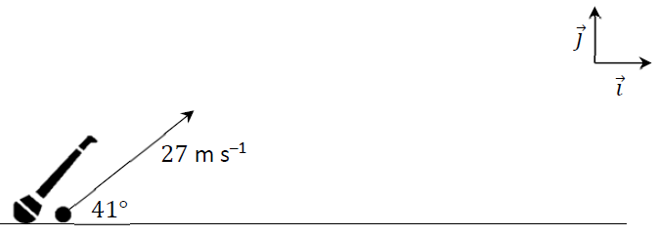
A camogie player strikes a sliotar off the horizontal ground. It travels with an initial velocity of 27 m ^{–1} at an angle of 41° to the ground, as shown in the diagram.

- Express the initial velocity of the sliotar in terms of the unit vectors $\vec{i}$ and $\vec{j}$.
The motion of the sliotar may be modelled as projectile motion in a vertical plane, ignoring the effects of wind and the effects of air resistance.

- Calculate the speed and direction of the sliotar 0.5 s after it is struck.
- Calculate the time it takes for the sliotar to reach its maximum height.
- Calculate the maximum height of the sliotar.
- The crossbar in a camogie goal is 2.5 m above the ground. Calculate the time interval during which the sliotar is at least 2.5 m above the ground.
- The graph below shows the predicted path of the sliotar when the effects of wind and the effects of air resistance are ignored. The graph is not drawn to scale.
- Using the same axes, sketch the path you would expect the sliotar to take if the model took into account the effects of air resistance (but not the effects of wind).
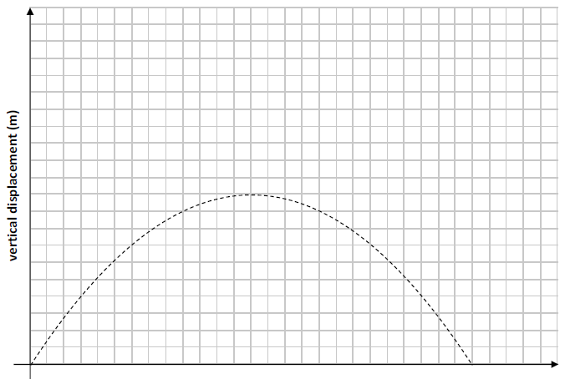

2023 OL Question 5 (a)

A particle is projected through the air with a velocity of 14𝚤⃗ + 24.5𝚥⃗ m s^{–1} from horizontal ground. The effects of air resistance and wind may be ignored.

- Calculate the time of flight of the particle.
- Calculate the maximum range of the particle.
- Calculate the times when the particle is at a height of 20 m above the ground.

- The graph below represents the predicted path of this particle when the effects of wind and air resistance are ignored. The graph is not drawn to scale.

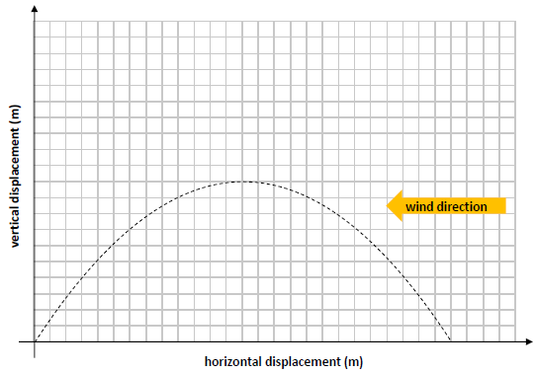
- Using the same axes, sketch the path you would expect the particle to take if the model took into account the effects of wind blowing from the east (but not the effects of air resistance).

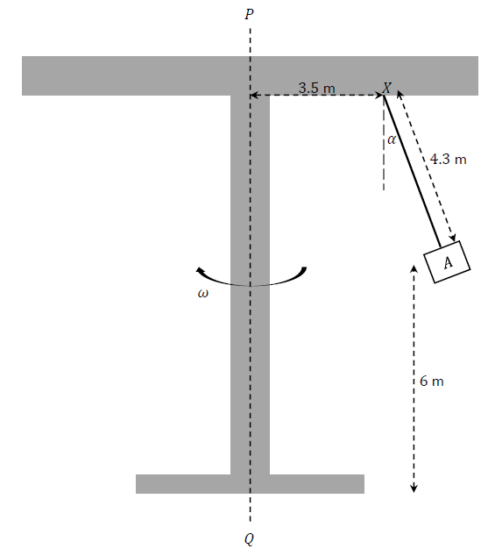
2023 HL Question 3

The person sitting in seat 𝐴 throws a small orange into the air.
The person imparts an upward vertical velocity component of 4 m s^{–1} to the orange.
Calculate the time from when the orange is thrown until it hits the ground

Sample Paper HL Question 4 (a)
A ball is projected from a point on horizontal ground, with initial speed 𝑢 and at an angle 𝛼
to the horizontal. The ball reaches a maximum height of 𝐻₀ above the horizontal.
Upon landing, the ball bounces with a maximum height of 𝐻₁.

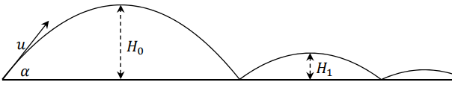

The coefficient of restitution between the ball and the ground is 𝑒.
- Calculate $\frac{H_{0}}{H_{1}}$.

- The ball continues bouncing. Find an expression (in terms of 𝑒 and 𝐻₀) for 𝐻₅, the maximum height of the ball after it lands on the ground for the fifth time.

2023 HL Question 8
Two balls, 𝑃 and 𝑄, are projected into the air from points 𝐴 and 𝐵, which are a distance 𝐷 apart along the horizontal 𝚤⃗ axis. The motion of the balls may be modelled as projectile motion in a vertical plane, ignoring the effects of air resistance.
𝑃 is projected from point 𝐴 at time 𝑡 = 0 s with initial velocity 38 m s^{–1} at 41° to 𝐴𝐵.
𝑄 is projected from point 𝐵 at time 𝑡 = 1 s with initial velocity 𝑢 m s^{–1} at 64° to 𝐵𝐴.
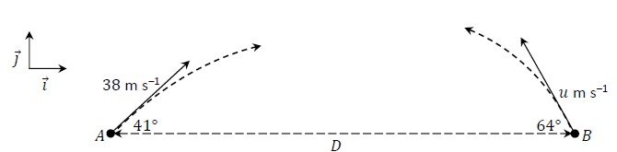

𝑃 and 𝑄 collide in mid‐air when 𝑡 = 3 s.

- Show that 𝑢 = 28 m s^{–1} to the nearest whole number.
- Calculate 𝐷.

- In terms of 𝚤⃗ and 𝚥⃗, calculate $\vec{v_{P}}$, the velocity of 𝑃, and $\vec{v_{Q}}$, the velocity of 𝑄, when the balls collide, i.e. when 𝑡 = 3 s.

- Calculate the dot product of $\vec{v_{P}}$ and $\vec{v_{Q}}$ when 𝑡 = 3 s.

- Hence or otherwise calculate the acute angle between $\vec{v_{P}}$ and $\vec{v_{Q}}$ when 𝑡 = 3 s.

